

Annual Report

2025


Our Mission
Healthy lives for everyone through sustainable, innovative and compassionate care

Our Strategic Priorities
We aim to achieve our mission by focusing on three strategic goals:


Consumers, Care and Community
We will partner with consumers and communities to deliver the care they need to live healthy lives


People, Teams and Culture
We will co-create a culture where our people thrive, supporting healthy lives for everyone


Sustainability, Systems and Infrastructure
We will design and facilitate the delivery of progressive and sustainable healthcare


Our Values

Be the Best

We maximise our impact through learning and innovation

Be a Role Model
We take initiative and inspire others


Be Open and Honest

We demonstrate integrity through our actions, which are transparent and accountable

Be Compassionate and Respectful
We care with kindness and foster dignity and inclusion


Be Collaborative
We work as one Peninsula Health and seek diverse knowledge and perspectives
Peninsula Health acknowledges the Traditional Custodians of the lands where its health services are located. We acknowledge the Bunurong and Boon Wurrung people of the Kulin Nation. We pay our respects to Elders, past, present and emerging.

2024–25 Year in review


99,227 people attended our Emergency Departments

24,247 surgeries were performed by surgeons
102,106 people were treated in our hospitals


41,331 people were admitted to hospital from our Emergency Departments

2,494 babies were born

18,641 children were cared for in our Emergency Departments

98,989 prescription items were dispensed from our Pharmacy

164,599 X-rays and scans were performed
16,091 patients were treated by our Community Dental team

46,457 clients were kept safe at home by our MePACS personal alarm service


4,510 people received care in their home with our At Home services
4,491 sole workers were kept safe by MePACS in the community
Data may include some patients treated more than once.

Table of contents
Board Chair and Chief Executive’s Report 6
Introduction 6
Peninsula University Hospital: A new name for a new era 6
Delivering care and monitoring in the home 7
Bayside Health 8
Innovation and learning 8
Surgical initiatives 10
Research 11
The National Centre for Healthy Ageing (NCHA) 13
Capital works 13
Brand 15
Our People 15
Partnering with First Nations communities 16
Our supporters 18
Report of Operations 19
Peninsula Health at a Glance 19
Our local community area 20
Our Clinical Services 21
Our Governance and Organisational Structure 26
Board of Directors as at 30 June 2025 27
Board Committees as at 30 June 2025 32
Organisational Structure as at 30 June 2025 34
Our Workforce 35
Occupational Health and Safety 36
General Information 39
Additional information available on request 57
Thank you to our supporters 58
Other Reporting Requirements 60
Key Financial and Service Performance Reporting 61
Strategic Priorities 61
Performance Priorities 67
Financial Summary 71
Attestations 73
Disclosure Index 75
Annual Publications 77
Peninsula Health Financial Statements 78

Board Chair and Chief Executive’s Report

Introduction
The past year has been truly transformative, not just for Peninsula Health but also for the communities we serve across Frankston and the Mornington Peninsula.
Our teams have spent significant time preparing for the opening of the new hospital in Frankston, to be named Peninsula University Hospital, in early 2026. This change to the name of the hospital recognises our strong ties and commitment to research, teaching and learning in collaboration with Monash University, and the accessibility of the new facility to everyone on the Mornington Peninsula.
We also refreshed the health service brand in 2025 to better reflect who we are, what we do, and what we want to be known for: Healthy Lives for Life. As we prepare to merge with Alfred Health, Gippsland Southern Health Service, Bass Coast Health and Kooweerup Regional Health Service to form Bayside Health, we do so from a position of strength, compassion, and deep community connection.

Peninsula University Hospital: A new name for a new era
Among the most visible and exciting milestones in this transformation is the renaming of Frankston Hospital to Peninsula University Hospital in January 2026.
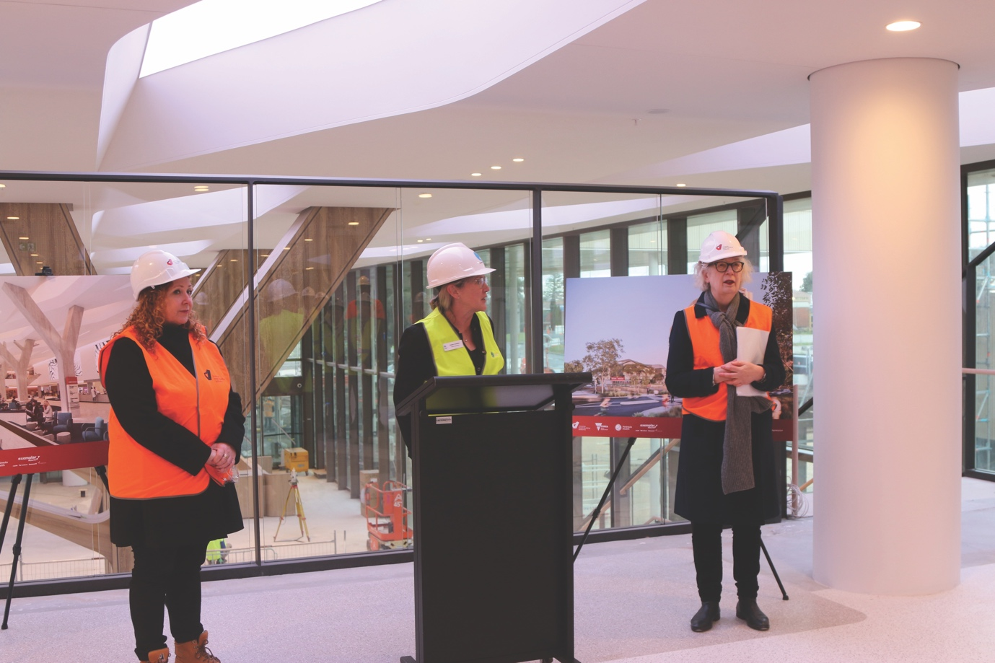
This new name reflects both the extraordinary facilities within the $1.1 billion redevelopment of the hospital, as well as our growing academic partnership with Monash University. Peninsula University Hospital honours our place on the Mornington Peninsula, and our future, as a centre of academic and clinical excellence. It signals a shift towards greater research capability, higher education integration, and the kind of innovation-led health care that will attract the best minds and benefit generations to come. The new clinical services tower will offer state-of-the-art surgical services, cancer care and maternity facilities, including a new Women’s and Children’s floor. Our Mental Health and Wellbeing Service will continue to grow with the opening of new integrated facilities for both adult and aged acute care. A helipad has been installed to ensure smooth and speedy access for any patients requiring urgent treatment.
Work on the new building has continued at a remarkable pace over the course of the last 12 months, with the final fit-out of the tower now underway. Peninsula University Hospital will incorporate outdoor areas for patients and staff on every level, with a spacious atrium and retail sector also being installed and finalised in the coming months. Staff will also benefit from a dedicated rest area, with access to outdoor spaces to relax away from the clinical environment in the warmer months.
From October to January, we will have greater access to the tower to complete our operationalising of the space, so that the first patients, clients and staff can move into the new wards and other areas from early 2026.

Delivering care and monitoring in the home
Peninsula Health’s At Home virtual monitoring service continues to transform health care within the comfort of people’s homes.
Since the service began, there has been an average growth rate of 13 new patients accepted by the service each month across Frankston and the Mornington Peninsula. This At Home monitoring service cares for patients with heart failure and respiratory conditions through virtual monitoring and providing care to clients in their own home. with the key aim of improved patient outcomes and reducing or preventing Emergency Department (ED) presentations and hospital admissions. The team assists people to detect and manage a deterioration in their condition as early as possible, and works to educate patients on how to self-manage their chronic condition.
Our MePACS Personal Alarm service is now caring for more than 48,000 clients across Australia. Our 24/7 call centre responds to more than 1,900 emergency alarms every day, with an average of 62 of those contacts being escalated daily to Triple Zero. Between 11am and 3pm every day, we contact between 500 - 700 clients who have failed to check in for their daily welfare check.
Working in collaboration with Peninsula Health, the MePACS customer care centre staff also commenced supporting the Virtual Monitoring Team in 2024, checking in on patients who have failed to complete their home-based health survey, and calling those patients who are unable to fill out their survey independently to assist them to complete.
Across all At Home services in 2024 we saw:
- 23% drop in ED presentations from aged-care facilities
- 12% increase in care delivered in the home
- 143 patients remotely monitored for cardiac and respiratory conditions
- 16% of rehabilitation and geriatric care delivered at home
- 12% increase in cancer care delivered at home
- tripling of lymphoedema services delivered at home
- 350% increase in Inflammatory Bowel Disease care delivered at home
- 50% reduction in unplanned readmissions for patients receiving acute care at home

Bayside Health
In early 2025, the Boards of Peninsula Health, Alfred Health, Kooweerup Regional Health Service, Bass Coast Health, and Gippsland Southern Health Service decided to merge to form Bayside Health.
The creation of Bayside Health stemmed from discussions between the five health services, drawing on their existing partnerships as well as the recommendations from the Victorian Government’s Health Services Plan.
All staff from the five health services will transfer across to Bayside Health on 1 January 2026. There will be no change to existing terms, conditions and entitlements for employees. All existing hospitals and healthcare sites operated by the five health services will continue to deliver programs and services for the community.
The new health service is an equitable joining of the five existing health services, and all hospitals and facilities will keep their names and identities across the new expanded region. We will keep our staff, patients and community up-to-date through regular communication and engagement over the course of the next year.
Through the voluntary merger, Bayside Health will care for more than 1.2 million people living in Victoria’s south-east and deliver even better and more connected care in the community for the newly expanded south-east region.

Innovation and learning
Peninsula Health continues to break new ground in many parts of healthcare delivery.
- Peninsula Health is leading the way in Australia in defining optimal molecular oncology care for our patients. This innovative approach will enhance access and equity, ensuring all eligible patients benefit from precision oncology regardless of tumour type or postcode, improving patient outcomes and experience through timely access to targeted therapies and clinical trials. It will support research and innovation, and positions Peninsula Health favourably among other cancer services, given we are the first in the state to pilot this model of care. As an Australian-first, a Molecular Oncology Care Coordinator was appointed in January 2025 as part of a 12-month project supported by a Southern Melbourne Integrated Cancer Services (SMICS) Innovation Grant. The role is multifaceted, providing support and education to patients and clinicians, implementing IT solutions, and establishing key relationships.
- Thanks to some unique innovations conceived and implemented by our Emergency Department (ED) teams, we are providing our community with the best in timely, world-class emergency care. In April to June 2025, Frankston and Rosebud Hospitals were the highest performing hospitals in the state for Ambulance Victoria offload times. This means patients are transferred into the ED faster, and ambulances can get back into the community sooner. With the key measure set by the Victorian Department of Health, Peninsula Health teams have consistently surpassed the state-wide target of transferring patients from the ambulance to ED in less than 40 minutes.
- Frankston Hospital became the third hospital in Victoria to introduce an Impella program in October, when the cardiology team acquired an Impella heart pump. This purchase was made possible due to our generous donor community, which raised significant funds through our tax appeal and regular giving program.
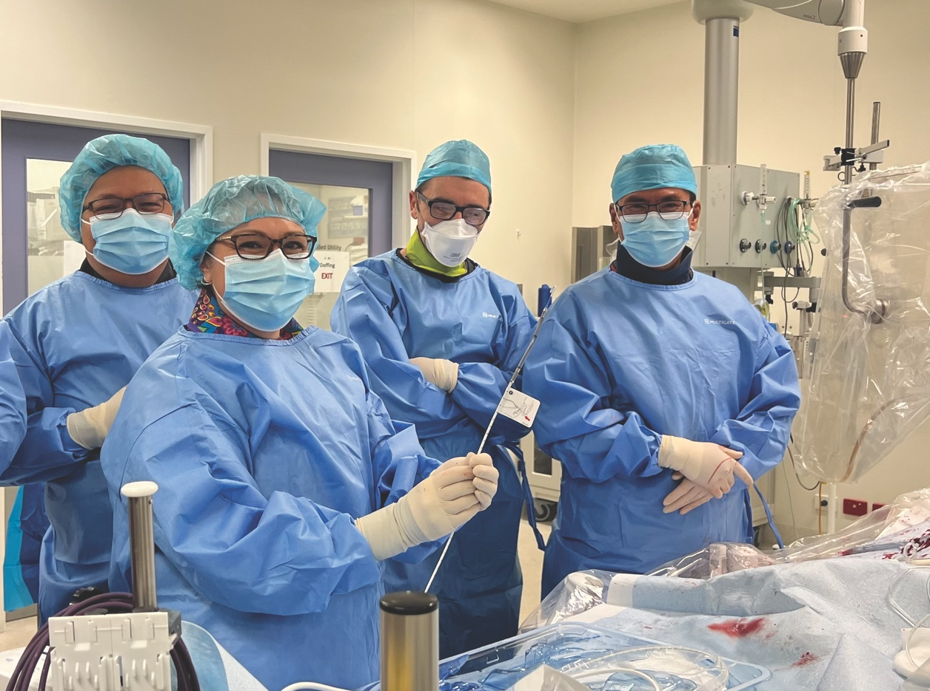
- Peninsula Health is the first health service in Victoria to establish a specialist nurse-led clinic for patients who return a positive stool sample in the Australian Government’s National Bowel Cancer Screening Program.

- Over the last 12 months under Head of Gastroenterology, Associate Professor Marcus Robertson, we have started a new service at the hospital for people with liver cancer, meaning we offer every treatment available for liver cancer in our catchment. In addition to the two new weekly clinics, two specialist nurses are in place to coordinate liver services for patients.
- Peninsula Health was the first health service in Victoria to go live with the new digital application SystemView. This Hospital and Health Analytic Solution provides real-time hospital insights into bed management, Emergency Department and outpatient visibility by pulling together data from across multiple Peninsula Health systems. The implementation of SystemView has enhanced our ability to coordinate patient access and demand across healthcare services. Peninsula Health collaborated with Healthcare Logic, the vendor for SystemView, and Health Technology Services, a unit within the Department of Health, to design and implement this new system.
We have grown our education and training capacity, welcoming hundreds of students, interns, residents and registrars this year. Our simulation and clinical education programs ensure that staff are constantly learning, adapting and leading best practice.
As Peninsula University Hospital opens its doors in January 2026, we will continue to develop as a university-affiliated health service that not only delivers excellent care, but helps shape the future of health care in Australia.

Surgical initiatives
As part of a special initiative between Stryker and Peninsula Health, we were able to obtain a loan of a second MAKO robot to enable two intensive surgery sessions at the Frankston Hospital theatre complex.
The MAKO robot uses CT scans to create a 3D virtual model of a patient’s joint, allowing for improved surgical procedures, and better and speedier recovery times.
The additional surgery sessions allowed patients who were scheduled for surgery to have their joint replaced using the MAKO robotic system. During these intensive sessions, 40 hip and knee replacements were performed, which were in addition to the ongoing MAKO robotics arthroplasty surgery at Frankston Public Surgical Centre (FPSC).
Another significant achievement in surgical care was achieved in endoscopy. We provided care for people requiring endoscopy services with 91 per cent of patients receiving their surgery within the recommended time. The additional capacity at FPSC has supported more than 2,500 patients to receive endoscopy procedures in the reporting period, which is a significant increase of 750 surgeries from the previous year.

Other initiatives to improve the management of people waiting for an endoscopy procedure include:
- the implementation of electronic tools for audit and validation
- the development of an electronic health questionnaire
- the instigation of electronic referrals for procedures
- improved pre-operative bowel preparation instructions and communication with patients.
We also further improved our processes with:
- the implementation of Digital Endoscopy Referrals; these are legible and standardised, providing clear guidance for perioperative management including anticoagulant, antiplatelet and antidiabetic medication management
- streamlined post-endoscopy pathways to improve follow-up of patients with clinically urgent histopathology and communication to GPs post endoscopy.
The implementation of an outpatient clinic to follow up positive at home stool tests has been successful. As a result of the clinic, all those patients are seen within two weeks for triaging and assessment to determine if a scope is required and clinically indicated. This has created a streamlined process from a GP referral to patients receiving a date for their procedure in a timely manner.

Research
This year has seen enormous progress in research at Peninsula Health, which is consistent with the emergence of the new Peninsula University Hospital set to open in January 2026.
A new Research Strategy will be launched in October 2025 for the next four years. Our vision is to establish a culture where research is integral to care.
We were delighted that some of our senior staff were recognised with Adjunct appointments at Monash University during the last 12 months:
- Dr Charlene Lee – Adjunct Lecturer (Department of Geriatric Medicine)
- Dr Darsim Haji – Adjunct Lecturer (Emergency, ICU Diagnostic & Pharmacy)
- Dr Maheswaran Masilamany – Adjunct Lecturer (Emergency, ICU, Diagnostic and Pharmacy)
- Dr Chris Karayiannis – Adjunct Lecturer (Department of Medicine)
- Dr Antonio D’Costa – Adjunct Senior Lecturer (Department of Mental Health)
- Dr Peter Francis – Adjunct Senior Lecturer (Surgery and Anaesthetics)
- Dr Jonathan Henry – Adjunct Lecturer (Emergency, ICU, Diagnostic & Pharmacy)

Highlights
Key conjoint academic appointments with Monash University include:
- Associate Professor Cath Aspinall, Associate Professor in Nursing, in the School of Nursing and Midwifery
- Associate Professor Mahesh Iddawela, Head of Medical Oncology and Associate Professor in Oncology, School of Translational Medicine.
The appointments above form the beginning of further planned strategic clinical-academic appointments, who by their activities and mentoring, will drive excellence in translational research and care for patients presenting to Peninsula Health.
- A substantial increase in the volume of clinical trials conducted in Peninsula Health (>90), ensuring access to new and developing therapies for our community.
- Strengthening research governance through a large body of work conducted by our Office for Research, to ensure that clinical trials and research at Peninsula Health conform to the new accreditation standards of the National Clinical Trials Governance Framework.
We would also like to recognise significant achievements from key senior staff.
- Dr Laura Jolliffe – Allied Health Research Translation Lead, was awarded the inaugural Monash Partners Award for Health Services research, receiving the award from Professor Steve Wesselingh, CEO of the National Health and Medical Research Council.
- Dr Marianne Coleman – post-doctoral fellow, National Centre for Healthy Ageing, was successful in securing a competitive $400,000 Mid-Career Fellowship from the Dementia Australia Research Foundation to improve eye-care for people with dementia.
- Professor Velandai Srikanth – Director, National Centre for Healthy Ageing, received a Medical Research Future Fund grant of $2 million with interstate collaborators for developing an electronic frailty index for acute care in hospitals.
- Associate Professor Nadine Andrew – Research Data Lead, National Centre for Healthy Ageing, secured a $500,000 grant from the Australian Research Data Commons, as well as $1.5 million from the Ideas Grant Scheme of the NHMRC, both going towards enhancing data and translational capacity of the NCHA Healthy Ageing Data Platform.
- Dr Taya Collyer and team from Peninsula Health and the National Centre for Healthy Ageing led a first-in country development of algorithms for predicting likelihood of dementia in hospitalised patients, using artificial intelligence techniques to derive data from unstructured text-based data.

The National Centre for Healthy Ageing (NCHA)
The National Centre for Healthy Ageing (NCHA) is now close to the completion of the establishment phase.
In addition to the Healthy Ageing Data Platform, and the National Aged Care Research Network, which were early milestones in development, six different technology-supported simulation facilities are to be unveiled by November 2025. These are all nationally unique facilities set within Monash University, Peninsula Health, and community campuses. On Peninsula Health grounds, the Australian-first Smart Ward will be opened at the Flinders Ward at The Mornington Centre. This innovative technology can generate sensor-based activity data and health information to improve care quality for our patients with complex aged-care needs.
The NCHA also launched a new platform to support impactful consumer engagement in research during the reporting period. The platform, Voice™ Australia, was originally developed in 2015 by Newcastle University in the United Kingdom, and after success in the UK has expanded globally. The platform offers a digital environment enabling the NCHA and its partners to easily engage and maintain a large and thriving community of people who are interested in leveraging their lived experiences for research and innovation.
Nurse Unit Manager, Felicity Leavold, and the Acute Care of the Elderly (ACE) nursing team have made a remarkable contribution to dementia care research, in a co-design study alongside Associate Professor Chris Moran and experts from Monash University under the NCHA. The research focuses on understanding how hospital environments can better cater to support individuals with dementia, ensuring more compassionate and person-centred care. The key findings of the study have been published in BMC Geriatrics, titled “Understanding and Integrating the Needs and Preferences of People Living with Dementia in the Inpatient Setting: A Qualitative Study.”

Capital works
The physical transformation of our health service is not limited to the new hospital in Frankston. This year we made significant progress in upgrading our mental health and wellbeing facilities in the community. We also continued to oversee the construction of the new Early Parenting Centre at Hastings, in partnership with the Queen Elizabeth Centre, which will run the facility when it opens next year.
In April, we completed some significant improvements at The Mornington Centre. Over the course of 12 months working alongside the builder Quadracon, the patient bathrooms and rooms on the Sorrento and Gunnamatta wards were renovated, along with some common areas, while additional hoists were also fitted for greater safety and comfort for patients and staff. The works have greatly enhanced the environment for everyone spending time in the hospital.

We opened the renovated Youth Prevention and Recovery Care (YPARC) facility in Frankston in the middle of the year. The upgrade delivered refurbished bedrooms and bedroom pods, a new shared kitchen, living and activity spaces and more outdoor areas. The project was delivered by the Victorian Health Building Authority in partnership with us and the builder, Bowden Corporation. This building is part of our youth mental health precinct, with further works underway on Yuille Street to provide a permanent home for our newly commenced 0-11 years Mental Health and Wellbeing service, which commenced in late 2024, previously provided by Monash Health.
Also in mental health and wellbeing, the $1 million refurbishment of our Community Care Unit was completed, with significant renovation works to the nine residential units and the administration area. All of the residential units have been re-painted, the kitchens and bathrooms have been updated, new blinds and lights have been installed, as well as air conditioning and ceiling fans. The investment has delivered a significant facelift to the 30-year-old residential units. This will help us to continue to deliver the best care for people seeking treatment for mental health concerns and substance use challenges.
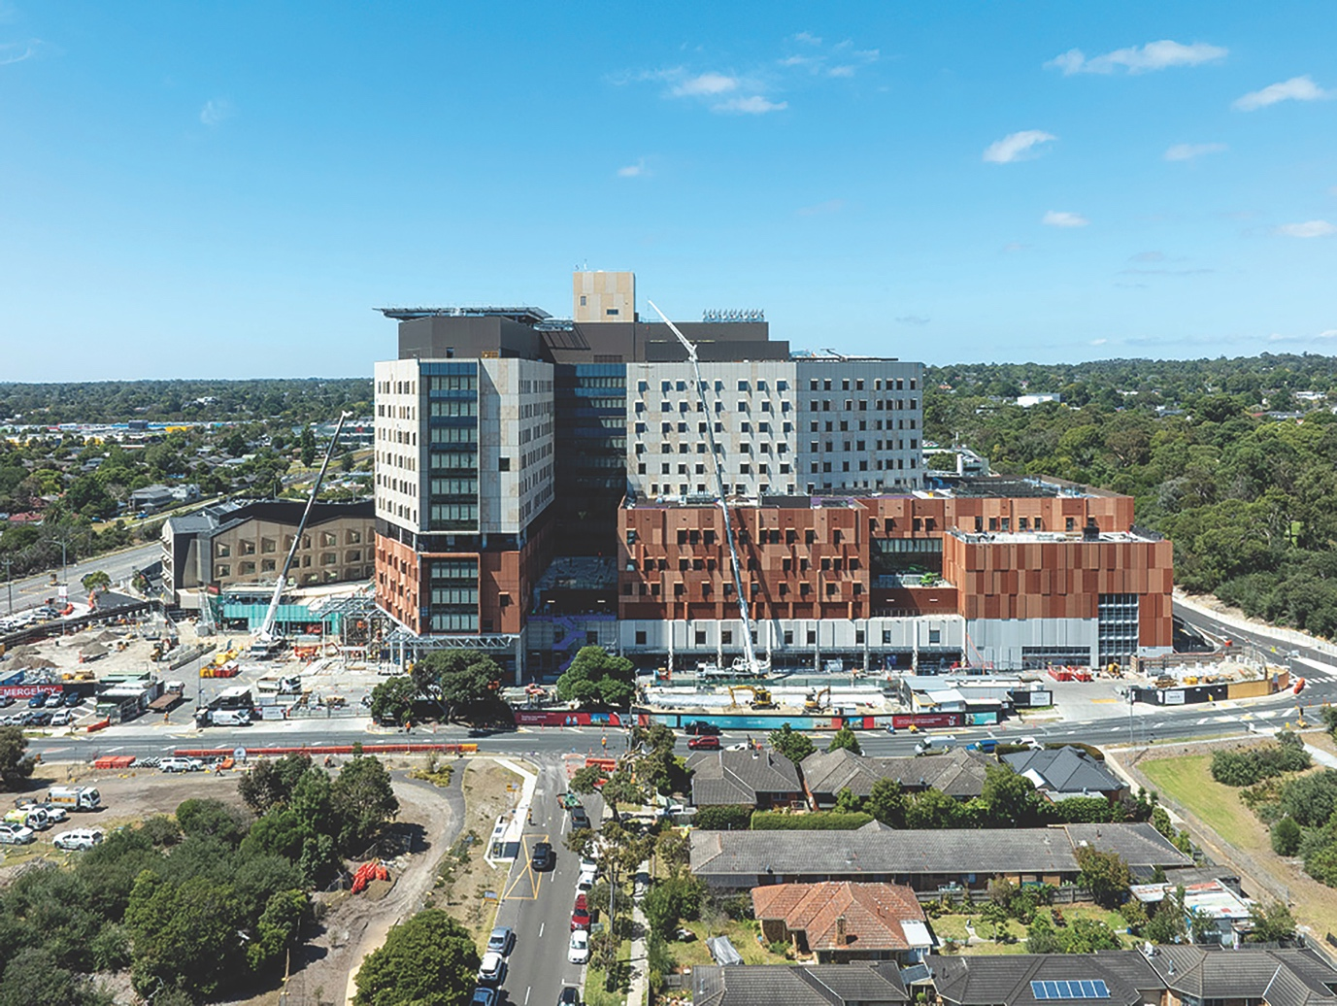

Brand

Aligned with our strategic aim of Healthy Lives 2028, we refreshed our brand in 2025 to mark a new chapter in our commitment to providing compassionate, connected care for our community, driving innovation, and improving patient outcomes through evidence-based research.
Our defined brand and refreshed visual identity, along with a change in communication focus, is designed to reflect who we’ve become, what we do well, and where we are headed. The refreshed brand provides visual consistency for our people across all our sites, removing any confusion for the local community caused by maintaining differing representations of Peninsula Health at our hospitals and healthcare facilities.
When the merger to form Bayside Health takes effect, the Peninsula Health brand will remain in place for our community, on our website and at our hospitals and health care sites, so the roll-out of our refreshed identity will continue to touch staff and the public over the coming years. Our realised brand essence, Healthy Lives for Life, speaks to our strengths in local community connectivity and person-centred care, while also bringing our innovation and research achievements to the forefront.

Our People
Many of our dedicated team members were recognised over the last year and we are delighted to highlight some of them below.
- Dr Astha Tomar – assumed the role of President of the Royal Australian and New Zealand College of Psychiatrists in May 2025 for a two-year term.
- Dr Nisha Khot – Clinical Director, Obstetrics and Gynaecology – appointed as the President-Elect for the Fourteenth Royal Australian and New Zealand College of Obstetricians and Gynaecologists (RANZCOG) Council, serving from October 2025 to October 2027.
- Judi McKee OAM – retired Peninsula Health nurse - was awarded the Medal of the Order of Australia (OAM) in the 2025 Australia Day Honours, in recognition of her exceptional service to the community.

- Dr Krystle Chong – Peninsula Health Obstetrics and Gynaecology Registrar and Researcher – co-authored a ground-breaking primer on ectopic pregnancy for Nature Reviews Disease Primers.
- Melissa Molenaar – Director of Nursing, The Mornington Centre - was awarded a Bachelor of Nursing Honours Scholarship by Monash University and Peninsula Health, allowing her to undertake an honours degree in Nursing or Midwifery.
- Jodie Howard – Registered Midwife – was awarded a Bachelor of Nursing Honours Scholarship by Monash University and Peninsula Health, allowing her to undertake an honours degree in Nursing or Midwifery.
- Colleen White – Operations Director, Women’s, Children’s and Adolescent Health – was shortlisted as a finalist for the HESTA Midwife of the Year award.
- Jessica Reece – AOD Traineeship Supervisor – won the Centre for Mental Health Learning (CMHL) Award for Excellence in Education.
- Gemma Bourke – Dietitian – received an Inspiring Educator Award from Monash University. Nominated by Monash University students, Gemma was recognised for her outstanding contributions to education and student mentorship.
- Anneliese Twigg – Health Promotion Practitioner - received an Inspiring Educator Award from Monash University. Nominated by Monash University students, Anneliese was recognised for her outstanding contributions to education and student mentorship.
- Dr Helen Kolawole – Sessional Specialist Anaesthetist - received the ANZCA Medal at the annual College Ceremony of the Australian and New Zealand College of Anaesthetists in Brisbane. Dr Kolawole was among six anaesthetists awarded for their significant and continuous contributions to local, Australian, New Zealand, and international anaesthesia throughout their careers.
In addition, we held our inaugural Nursing and Midwifery Excellence Awards during the reporting period, with separate events held in our different hospitals, as well as in the field of mental health and wellbeing.
Finally, on a sad note, our inaugural Clinical Director of Surgery at Frankston Hospital, Professor Colin Russell, passed away in September 2024. Professor Russell’s legacy will live on in Peninsula University Hospital with the surgical meeting room continuing to be named in his honour.

Partnering with First Nations communities
This year saw the development of our Innovate Reconciliation Action Plan (RAP). This document is a roadmap for embedding respect, equity and self-determination into every part of our work.
We have worked in close collaboration with the Bunurong Land Council, the Victorian Aboriginal Community Controlled Health Organisation (VACCHO), and our First Nations staff members, patients and families to ensure our services are safe and responsive. Our particular thanks go to Aunty Helen Bnads, our Cultural Lead and Elder (at the lectern in the below image), who continues to lead our work in this area, ably supported by Kunal Mahajan, our Aboriginal and Allied Health Manager.
Local artist and proud Kamilaroi man, Eamon Roberts, unveiled his latest artwork during National Reconciliation Week. Titled Upon Our Journey, the piece was commissioned by Peninsula Health’s Aboriginal Health team for the Palliative Care Unit at Golf Links Road Rehabilitation Centre. The artwork symbolises our birth into the Dreaming and the journey every person takes through life, represented by the returning boomerang, completing the cycle of life. Eamon’s artistic contributions extend beyond this latest piece. His work also features on our extremely popular Aboriginal Health uniforms, and is the base for the Don’t Be Shy, Identify campaign. Eamon’s art reflects his deep commitment to sharing and preserving cultural narratives through visual storytelling.
During NAIDOC Week, there was a display of First Nations’ artwork at our Tarnbuk Centre in Frankston. The 16 pieces of artwork were purchased through
The Torch, which is a not-for-profit group that provides cultural and arts support to First Nations people in Victoria.


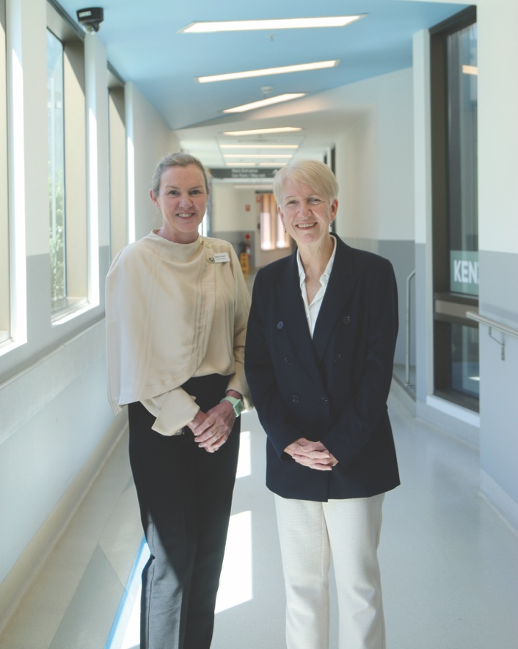
Our supporters
We would like to thank our team of volunteers, consumer advisors and donors for their enormous contribution to our health service. More than 450 remarkable people donate their time to Peninsula Health, and we deeply appreciate the expertise, compassion and guidance that they provide to our staff and our patients across all our sites.
We are overwhelmed with the generosity of our donor community, who continue to donate or raise funds for us, so that we can offer the best care to our community, both close to home and in the home. You can read more about our donor community and the impact of their giving in this report.
We would also like to acknowledge the contribution, leadership and expertise of Michael Gorton AM, who left the organisation at the end of June. Michael spent two years leading Peninsula Health as Board Chair before taking on the role of Chair at Monash Health at the start of July, and we wish him well in the new role.
It is our great privilege to lead Peninsula Health at this time of change, as we help to shape the future of Bayside Health when it commences at the beginning of next year. Together with our people and our community, we are building a stronger, smarter, more connected health system.

We hope you enjoy reading our 2025 Annual Report.

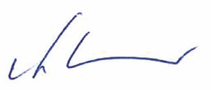
Ms Karen Corry
Board Chair
Peninsula Health

Associate Professor Helen Cooper
Chief Executive
Peninsula Health
August 2025

Report of Operations

Peninsula Health at a Glance
At Peninsula Health, we are a dedicated team driven to create a meaningful impact on people’s lives.
Our care goes beyond the conventional; we provide compassionate, connected health care that is accessible whenever and wherever it’s needed. We understand the impact poor health can have on individuals and their communities, which is why we are passionate about building healthier, stronger communities. Through our commitment to innovation, research, and a culture of respect, we partner with our communities to shape a brighter future for the people of Frankston, the Mornington Peninsula, and beyond. We strive to lead the way in integrated care by seamlessly connecting people, technology, and processes. Our vision is to ensure every interaction with us is person-centred, compassionate, and efficient. By providing a welcoming environment, and driving innovation through research and advanced services, we aim to leave a lasting, positive impact on the growing Mornington Peninsula region. Peninsula Health champions good health and wellbeing at every stage of life. Our goal is to ensure the people we care for enjoy healthy lives for life.
Peninsula Health is the major metropolitan health service for Frankston and the Mornington Peninsula. We care for a resident population of more than 315,000 people, with the area receiving close to eight million visitors annually. The majority of the visitors
are tourists in the summer months, which has a significant impact on presentations and care delivery at Rosebud Hospital.
We have five major hospitals:
- Frankston Hospital
- Rosebud Hospital
- Golf Links Road Rehabilitation Centre
- The Mornington Centre
- Frankston Public Surgical Centre
We have five community mental health facilities and five community health centres in:
- Frankston
- Mornington
- Rosebud
- Hastings
- Seaford

Our services for the community include care across the life continuum and are listed below.
We are a major teaching and research health facility, training the next generation of doctors, nurses, allied health professionals and support staff. We have strong partnerships with Monash University, Deakin University, La Trobe University, Chisholm Institute and Holmesglen Institute.
Our local community has some unique demographic features and challenges, including:
- a higher than average rate of population ageing
- a mix of wealth and extreme disadvantage
- higher than average rates of vulnerable children, homelessness and family violence
- higher than average rates of chronic diseases and mental health issues.
These factors create challenges in providing the best of care, where and when it is needed to respond to the needs of children, people with mental health issues, and older residents.
With 7,655 staff and 450 volunteers, consumer advisors and auxiliary members, our dedicated and highly skilled teams work together to provide safe, personal, effective and connected care, for people and families in Frankston and the Mornington Peninsula.

Our local community area
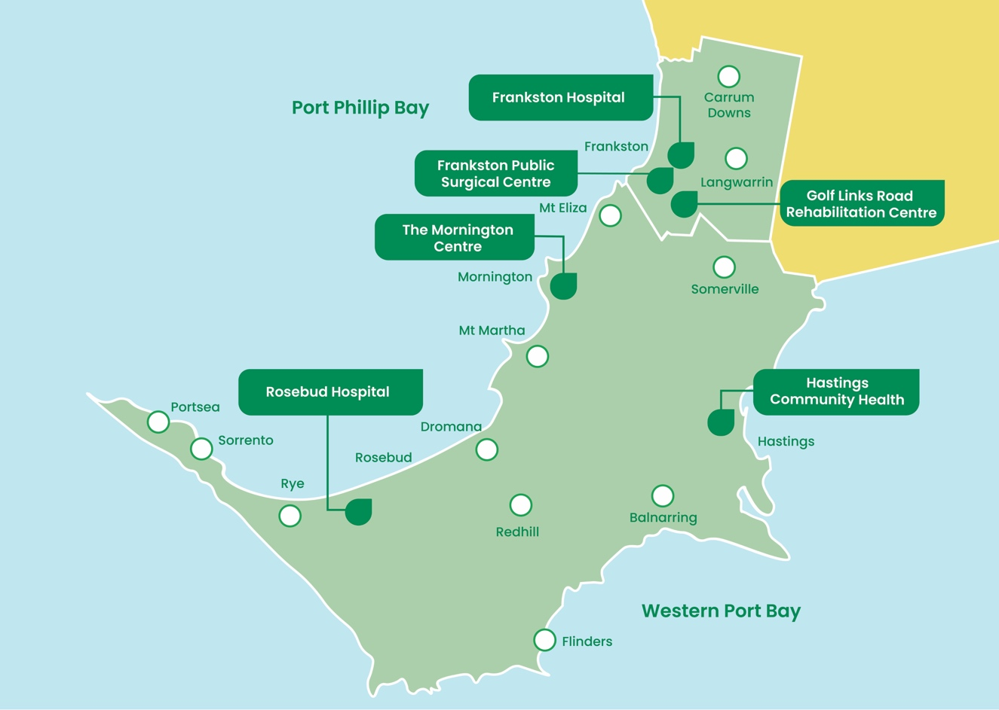

Our Clinical Services

Aged Care

Inpatient Services
- Geriatric Evaluation and Management
- Orthogeriatric Service
- Acute Care for the Elderly
- Sub-acute Assessment Service
- Residential Transitional Care Program

Community
- Aged Care Assessment Service (MEACAS)
- Regional Assessment Service
- Geriatric Medicine Clinic
- Cognitive, Dementia and Memory Service (CDAMS)
- Falls Prevention Service
- Continence and Urodynamics
- Chronic Wound Clinic
- Lymphoedema Service
- Specialist Outpatient Clinics

Allied Health
- Audiology
- Diversional Therapy
- Exercise Physiology
- Music Therapy
- Neuropsychology
- Nutrition and Dietetics
- Occupational Therapy
- Physiotherapy
- Podiatry
- Prosthetics and Orthotics
- Psychology
- Social Work
- Speech Pathology
- Spiritual Care

Community Health
- Aboriginal Health:
  - Including Elder/Cultural Lead
  - Aboriginal Hospital Liaison Officer
- Addiction Medicine
- Alcohol and Other Drugs Services:
  - Catchment Intake and Assessment
  - Non-residential Withdrawal Services
  - Counselling
  - Care and Recovery
  - Peer Support
  - Needle Syringe Program (SHARPS)
  - Youth Outreach
  - Supported Accommodation
  - Family Therapy
  - ResetLife Day Rehabilitation Program
  - Drink Drug Drive Behaviour Change Program
  - Pharmacotherapy service
- Forensic Mental Health in Community Health
- Community Care Program:
  - Care Coordination
  - Post-acute Care
  - Residential In-reach Program
- Hospital in the Home
- Advance Care Planning
- Early Intervention in Chronic Disease Services:
  - Cancer Rehabilitation Program
  - Cardiac Rehabilitation Program
  - Heart Failure Rehabilitation
  - Pulmonary Rehabilitation
  - Diabetes Education
- Commonwealth Home Support Program:
  - Podiatry
  - Dietetics
  - Physiotherapy
  - Exercise Physiology
  - Occupational Therapy
  - Speech Pathology
  - Nursing
  - Aboriginal Access and Support
  - Access and Support
  - Social Support Groups
- Home Care Packages
- Dental Services
- Mobile Integrated (MI) Health Program (Community Connections Homeless Program)
- Supporting Vulnerable Victorians in Residential Services (SAVVI) and Pension Level Project (PLP)
- Carer Support Program
- NDIS Services:
  - Adult Services
  - Children’s Services
  - Support Coordination
- Volunteers
- Community Health Children’s Services:
  - Podiatry
  - Dietetics
  - Physiotherapy
  - Occupational Therapy
  - Speech Pathology
  - Early Education
  - School Readiness Program
  - Healthy Mothers Healthy Babies
  - Aboriginal Healthy Start to Life
  - Family Violence Services:
    - Men’s Behaviour Change Program
    - Keeping Families Safe, Adolescent Violence Program
  - The Orange Door Family Violence Intake Service
  - Health Promotion
  - Sexual and Reproductive Health Service
  - Counselling

Emergency Medicine
  - Frankston Hospital Emergency Department
  - Rosebud Hospital Emergency Department

Intensive Care Medicine

Medical Services
  - Acute Care of the Elderly
  - Cardiology:
    - Cardiac Angiography
    - Cardiac Investigation Unit
    - Cardiac US
  - Endocrinology and Diabetes
  - Gastroenterology
  - General and Peri-operative Medicine
  - Haematology
  - Hospital in the Home
  - Infectious Diseases
  - Antimicrobial Stewardship
  - Infusion Centre
  - Medical Oncology
  - Neurology
  - Oncology
  - Renal Medicine
  - Respiratory and Sleep Medicine
  - Rheumatology

Mental Health Services

Specialist Mental Health Services
  - Clozapine Program
  - Families where a Parent has a Mental Illness (FaPMI)
  - Family Violence Advisor
  - Forensic Clinical Specialist Program
  - Neuropsychology
  - Therapy Service
  - Wellness Clinics (Dietetics, Exercise Physiology,
  - Music Therapy)
  - Consultation Liaison Services:
    - Mental Health Consultation Liaison General Hospital (MHCL GH)
    - Mental Health Consultation Liaison Emergency Department (MHCL ED)
    - Integrated Mental Health & AOD service
    - Perinatal Mental Health and Wellbeing Service
  - Mental Health and Alcohol and Other Drugs Crisis Hub

Infant Child and Youth Services
  - Community:
    - Infant, Child and Family (0-11 years) Stream
    - Youth Stream (12-25 years)
- Access Assessment, Brief Intervention and Consultation (ABC)
- Integrated Youth Assertive Treatment (IYAT)
- Residential:
    - Youth Prevention and Recovery Care (YPARC)

Adult Mental Health and Wellbeing Service (26-65 years)
- Inpatient:
    - Adult Acute Inpatient Unit - 2 West
    - Psychiatric Assessment and Planning Unit (PAPU)
- Residential:
    - Adult Prevention and Recovery Care (APARC)
    - Community Care Unit (CCU)
  - Community Programs:
    - Crisis Assessment and Treatment Team (CATT)
    - Early Discharge Management (EDM)
    - Mental Health Telephone Triage (MHTT)
    - Police and Ambulance and Clinician (PACER)
    - Adult Community Mental Health – Frankston and Mornington teams
    - Hospital Outreach Post-suicidal Engagement (HOPE)
    - Intensive Recovery Team (IRT)

Older Persons Mental Health and Wellbeing Service
- Community Programs
  - Intensive Community Assessment Treatment Team (APICATT)
  - Case Management Team
- Inpatient:
  - Older Adult Acute Inpatient Unit - 1 West
- Residential:
  - Carinya
- Frankston Local Adult and Older Adult Mental Health and Wellbeing Service (26+ years)
  - Delivered in partnership with Wellways and Mentis Assist

MePACS (Personal Alarm Call Service)

Paediatrics (Children’s Health)
- Child and Adolescent Health
- Home and Community Care-based services
- Paediatric Hospital in the Home
- OPD – general paediatrics and developmental/ behavioural clinics – Frankston and Hastings
- MDT Diabetes OPD Service
- Specialist Outpatient Clinics (including respiratory, neurology, dermatology, cardiology and paediatric gynaecology specialties)
- School-based Clinics
- Asthma Education

Pain Medicine
- Peninsula Health Integrated Pain Services
- Persistent Pain Management Service
- Pain Medicine Outpatient Clinic
- Pain Medicine Inpatient Consult Service

Pathology
- Mortuary Services
- Biochemistry
- Blood Banking Service
- Blood Product Management
- Bone Marrow Biopsies
- Cytology (including fine needle aspirates)
- Frozen Sections
- Haematology (including coagulation)
- Histopathology
- Immunology
- Microbiology
- Serology

Pharmacy
- Medicines Dispensing and Distribution
- Medicines Procurement
- Aseptic Manufacturing
- Clinical Trials Support
- Cancer Pharmacy Services
- Clinical Pharmacy Services
- Medication Protocol Maintenance
- Formulary Management

Radiology and Imaging
- Angiography
- CT
- Fluoroscopy
- General X-ray
- Interventional Radiology
- MRI
- Mammography
- Nuclear Medicine
- Ultrasound
- DEXA
- Dental OPG

Rehabilitation

Inpatient Services
- Amputee Rehabilitation
- General and Reconditioning Rehabilitation
- Stroke and Neuro-rehabilitation
- Orthopaedic Rehabilitation
- Rehab at Home

Ambulatory Rehabilitation (centre-based and home-based)
- @home Rehab/GEM/Palliative Care Program
- Community Rehabilitation Program
- Amputee Rehabilitation Clinic
- @home Orthopaedic Program
- General Community Rehabilitation
- Movement Disorders Clinic
- Neuro-rehabilitation Clinic
- Spasticity Clinic
- Movement Disorders Program
- @home Neurological Program

Supportive and Palliative Care
- Inpatient Palliative Care Unit
- Palliative Care Consult Service
- Supportive and Palliative Care Clinic

Surgical and Anaesthetic Services
- Anaesthesia, Acute Pain Management and Perioperative Medicine
- Breast and Endocrine Surgery
- Colorectal Surgery
- Ear, Nose and Throat Surgery
- Gastrointestinal Endoscopy
- General Surgery
- HepatoPancreatoBiliary and Upper Gastrointestinal Surgery
- Maxillo Facial Surgery
- Multidisciplinary Cancer Services
- Orthopaedic Surgery
- Otolaryngology and Head and Neck Surgery
- Plastic and Reconstructive Surgery
- Skin Integrity (wound care)
- Specialist Outpatient Clinics
- Stomal Therapy
- Urological Surgery
- Vascular Surgery

Women’s Health
- Acute and Perioperative Gynaecology
- Urogynaecology Outpatient Clinic
- Outpatient Gynaecology Clinic
- Colposcopy Clinic
- Sexual Health Clinic
- Outpatient Hysteroscopy Service
- Gynaecological Oncology Services
- Early Pregnancy and Perinatal Assessment Service
- Specialist Obstetrics and Midwifery Pregnancy Care
- Fetal Diagnostic Unit
- Complex Pregnancy Clinic
- Continuity of Midwifery Care
- (Midwifery Group Practice)
- Maternity and Newborn Care
- Special Care Nursery
- (premature and sick newborn babies)
- Maternity Hospital in the Home and Midwifery
- Home Care
- Neonatal Hospital in the Home

For further information about our services, please visit our website: www.peninsulahealth.org.au

Our Governance and Organisational Structure

Manner of Establishment
Peninsula Health is one of 12 metropolitan public health services in Victoria. It was established in 2000 under section 70 of the Health Services Act 1998, and was reconstituted on 1 July 2008 to amalgamate the previous Peninsula Health and the former Peninsula Community Health Service.
Peninsula Health reports to Victoria’s:
- Minister for Health and Ambulance Services: The Hon Mary-Anne Thomas from 1 July 2024 to 30 June 2025
- Minister for Health Infrastructure: The Hon Mary-Anne Thomas from 1 July 2024 to 19 December 2024
- The Hon Melissa Horne from 19 December 2024 to 30 June 2025
- Minister for Mental Health and Ageing: The Hon Ingrid Stitt from 1 July 2024 to 30 June 2025
- Minister for Disability and Children: The Hon Lizzie Blandthorn from 1 July 2024 to 30 June 2025.
The functions of a public health service Board are outlined in the Health Services Act 1988 (Vic) and include establishing, maintaining and monitoring the performance of systems to ensure the health service meets community needs.

Purpose, Functions, Powers and Duties
The core objective of Peninsula Health is to provide public health services in accordance with the principles established as guidelines for the delivery of public hospital services in Victoria under section 17AA of the Health Services Act 1988.
The health service operates across a number of sites, providing a broad range of services including:
- acute care at Frankston Hospital and Rosebud Hospital
- dedicated surgical care at Frankston Public Surgical Centre
- geriatric evaluation and management, rehabilitation, palliative care and residential services at Mornington, Frankston and Rosebud
- mental health services at Frankston, Hastings and Rosebud
- community health services at Frankston, Rosebud, Mornington and Hastings
- a patient alarm and monitoring service (MePACS).
As at 30 June 2025, Peninsula Health employed 7,655 staff and was supported by 450 volunteers, consumer advisors and auxiliary members.

Governance
Peninsula Health’s Board of Directors is appointed by the Governor-in-Council on the recommendation of the Minister for Health. Directors are usually appointed for a term of three years, with members eligible to apply for reappointment. The Minister for Health requires the Board to develop a Strategic Plan and to ensure accountable and efficient provision of health services.
The Board of Directors is responsible for the governance and strategic direction of Peninsula Health and works to ensure the services provided by Peninsula Health comply with the requirements of the Health Services Act 1988 (Vic) as well as the purpose, vision and goals of Peninsula Health.
During 2024–25, the Minister for Health set a Statement of Priorities of funding, activity and service performance for Peninsula Health. The Board held 11 meetings in the financial year ending 30 June 2025. At these meetings, members of the Peninsula Health Executive presented reports on their areas of responsibility as required.

Board of Directors as at 30 June 2025

Mr Michael Gorton AM (Board Chair)
MAICD, MCSP, Grad Dip Human Services Research

Appointed: 1 July 2023
Member: Audit and Risk Committee; Community Advisory Committee; Finance; Projects and Resources Committee and Remuneration and Nominations Committee
Mr Michael Gorton AM is a senior partner at Russell Kennedy Lawyers and has more than 30 years’ experience advising the health and medical sector, assisting boards of health organisations to understand their legal obligations for effective governance structures, governance policies and implementing risk-management strategies.
Mr Gorton is the Chair of Wellways Australia, Chair of Holmesglen Institute (TAFE) and Board member of Latrobe Regional Health. He is the former Chair of Alfred Health, a past Board member of Ambulance Victoria and is the former Chair of the Australian Health Practitioner Regulation Agency (AHPRA) and former Board member of the Australasian College for Emergency Medicine. He is a former Chair of the Victorian Equal Opportunity and Human Rights Commission.
Mr Gorton held the Chair role from 1 July 2023 to 30 June 2025, before he was appointed Chair of Monash Health Board of Directors 1 July 2025.

Ms Karen Corry (Deputy Chair) B.COM, FCA, FAICD

Appointed: 22 August 2017
Member: Finance, Projects and Resources Committee; and Audit and Risk Committee
Ms Karen Corry is an experienced board director and business leader. As a partner at KPMG, her work focused on business consulting, strategic planning and digital technology. Combining her digital skills with her audit, risk and financial management experience, she led a consulting business for over 15 years prior to becoming a non-executive director. She has been a board member and Chair of government, ASX-listed and not-for-profit organisations. Ms Corry currently Chairs the Australian Community Support Organisation (ACSO) and was the former Chair of the Cultural Development Network, as well as the previous Chair of the finance and audit committees at Holmesglen Institute, ACMI and Global Health Ltd. She is a Fellow of the Institute of Chartered Accountants and the Australian Institute of Company Directors.

Ms Kirsten Mander LLM, FAICD, FGIA

Appointed: 22 August 2017
Chair: Audit and Risk Committee
Member: Quality, Safety and People Committee
Ms Kirsten Mander is an experienced director, businesswoman and lawyer. She is currently Chair of the Audit and Risk Committee of Peninsula Health and chair of Legal Super. Until recently, she was Chair of the International Women’s Development Agency and the Victorian Assisted Reproductive Treatment Authority, and has been a director on various other boards, including Swinburne University, RT Health and the Law Institute of Victoria.
Previously, she had many years’ experience as a senior executive, general counsel and company secretary for a number of Australia’s top companies including Australian Unity, Sigma Pharmaceuticals and Western Mining, working throughout Australasia, Asia and the former Soviet Union.
Ms Mander holds a Master of Laws from The University of Melbourne and is a Fellow of the Australian Institute of Company Directors and the Governance Institute of Australia.

Mr Hamish Park B.COM, BA, ALM, GAICD

Appointed: 1 July 2020
Chair: Quality, Safety and People Committee
Member: Community Advisory Committee; and Finance, Projects and Resources Committee
Mr Hamish Park is an executive adviser, facilitator, trainer and board director with extensive public sector experience across all three tiers of government. He specialises in leadership development, working with boards and executives to lift the performance capability of their organisations.
Mr Park is a Director of Melbourne Leadership Group and a Senior Fellow at The University of Melbourne’s School of Government. He has worked with some of Australia’s foremost private institutions, including management consulting roles with EY, PwC, KPMG, ANZ Bank, National Australia Bank and Telstra. He also serves on the board of the charity Dine For A Cure, which has raised over $1 million in medical research funding.

Ms Sylvia Hadjiantoniou EMBA, B.COM, GAICD

Appointed: 1 July 2019
Member: Finance; Projects and Resources Committee
Ms Sylvia Hadjiantoniou is an experienced Board Director and Executive.
Ms Hadjiantoniou is a transformational leader who has worked across the public, private and not-for-profit sectors. In these roles, she has collaborated with multisector partners to deliver large-scale capital projects, develop precincts and manage organisational transformations. She is committed to advancing social justice by providing support services and improving access to affordable housing, community infrastructure, health care and education. Ms Hadjiantoniou holds a Bachelor of Commerce and an EMBA from Monash University. She has also obtained her Victorian Builder’s Licence and is a Graduate of the Australian Institute of Company Directors.

Ms Rita Cincotta BBUSA, Masters of Industrial and Employee Relations, GAICD

Appointed: 1 July 2018
Chair: Remuneration and Nominations Committee
Member: Community Advisory Committee; Quality, Safety and People Committee; Audit and Risk Committee
Ms Rita Cincotta is an experienced human resources practitioner, with industry experience in health, technology, financial services and higher education.
She is a Director and Principal Consultant at Human Dimensions, which specialises in employee experience, organisational culture and enhancing team performance.
Ms Cincotta is the Deputy Chair at Left Write Hook, as well as being the Chair of the Finance, Audit and Risk Committee.
Prior to embarking on a portfolio career, Ms Cincotta was the Vice-President People and Culture at Swinburne University of Technology, where she was a member of the Swinburne Executive Group, Chair of the Science and Australia Gender Equity (SAGE) Committee and Chair of the Financial Inclusion Action Plan (FIAP) group.

Professor Mark Frydenberg MBBS, FRACS, FAICD

Appointed: 1 July 2021
Member: Finance, Projects and Resources Committee; Quality, Safety and People Committee; Remuneration and Nominations Committee
Professor Mark Frydenberg was awarded the Fellowship of the Royal Australasian College of Surgeons in 1990, and then completed a formal clinical urological oncology fellowship at the Mayo Clinic, Minnesota, USA.
Upon returning to Australia, he was appointed as a urologist at Monash Health and the Royal Melbourne Hospital, and in 1997 was promoted to Associate Professor in the Department of Surgery, Faculty of Medicine, Nursing and Health Sciences, Monash University, and also became the Chairman of the Department of Urology, Monash Health, a position he held until 2017. He currently holds Professorial positions within the Department of Surgery, Faculty of Anatomy and Developmental Biology, and the School of Public Health and Preventative Medicine, at Monash University.
Professor Frydenberg has been involved in many leadership roles within Australia, and is a past president and current board member of the Urological Society of Australia and New Zealand (USANZ). He is a member of the Council of the Royal Australasian College of Surgeons and is the Chair of the Health Policy and Advocacy Committee. He also holds the position of the Academic Chair of Urology, Cabrini Institute, Cabrini Health.

Dr Tony Kambourakis MBBS, MPH, FACEM, FRACMA, FCHSM, MAICD

Appointed: 1 July 2023
Member: Audit and Risk Committee; Quality, Safety and People Committee.
Dr Tony Kambourakis is a medical specialist dual-qualified in emergency medicine and medical administration.
He is currently Executive Director Medical Services at Alfred Health and was previously Director of Emergency Medicine at Monash Medical Centre.
Dr Kambourakis’s experience and areas of interest include clinical governance; patient safety and serious incident management; disaster and emergency clinical response; new clinical procedures and technologies; governance of specialist training programs, and clinician professional development and support. Dr Kambourakis is a past clinical lead of Safer Care Victoria’s Emergency Care Clinical Network.
He is actively involved in inter-professional, undergraduate, and postgraduate medical education, and is a senior lecturer with the Monash University Central Clinical School and a member of the Board of Censors of the Royal Australasian College of Medical Administrators.

Mr Peter Joyce B.COM, FCPA, GAICD

Appointed: 1 July 2024
Chair: Finance, Projects and Resources Committee
Member: Audit and Risk Committee
Mr Peter Joyce has lengthy experience in the manufacturing and consumer products sector and worked for many years for the US consumer products company Sara Lee based in Australia, Singapore and The Netherlands. He has held various roles in finance, mergers and acquisitions and as a General Manager.
Mr Joyce has also worked in the credit card and financial services industry and in the IT sector in both Asia and Australia, and has been a consultant working with a number of organisations across various industries on financial planning and financial sustainability. He is a fellow of the Australian Society of Certified Practising Accountants and a graduate Member of the Australian Institute of Company Directors.
Between 2012 and 2023, Mr Joyce was the Executive Director Finance and the Chief Financial Officer of Alfred Health, which operates The Alfred, Caulfield and Sandringham hospitals, as well as a number of community based public health services. During that time, he was also involved with several sector-based projects.
Mr Joyce has a particular interest in the sustainable pricing and funding of public health, and has continued to work as a consultant in the financial sustainability in the health sector and as a member of the Expert Advisory Panel of Hospitals Victoria.
Mr Joyce is also a co-founder and Chair of the Advisory Board of a Cambodian Foundation since 2008, which supports under-privileged young people in Cambodia.

Board Committees as at 30 June 2025
Six committees provide specialist advice and support to the Board. The committees also assist the Board and senior management to meet the statutory, regulatory and operational requirements of the health service.

Finance, Projects and Resources Committee
The role of the Finance, Projects and Resources Committee is to assist the Board in the oversight and management of Peninsula Health’s financial performance and resources. The committee reviews all financial matters, management information, and internal control systems, and considers and makes recommendations to the Board on major and minor works.
Board members: Peter Joyce (Chair), Karen Corry, Michael Gorton AM, Sylvia Hadjiantoniou, Professor Mark Frydenberg and Hamish Park

Audit and Risk Committee
The role of the Audit and Risk Committee is to assist the Board in fulfilling its governance responsibilities under the Standing Directions of the Minister for Finance under the Financial Management Act 1994 (Vic). The committee liaises with the internal and external auditors; reviews and approves audit programs; and evaluates the adequacy and effectiveness of the overall governance framework operating within Peninsula Health. The committee receives reports via the compliance-monitoring framework and monitors all risk-management activities for Peninsula Health.
Board members: Kirsten Mander (Chair), Peter Joyce, Karen Corry, Rita Cincotta, Michael Gorton AM and Dr Tony Kambourakis

Quality, Safety and People Committee
The role of the Quality, Safety and People Committee is to assist the Board to monitor and improve the quality and effectiveness of the care provided by Peninsula Health. The committee is also responsible for the clinical risk-management activities, which are integrated with Peninsula Health’s quality systems.
Board members: Hamish Park (Chair), Rita Cincotta, Professor Mark Frydenberg,
Dr Tony Kambourakis and Kirsten Mander
Consumer members: John Clark-Kennedy, and Pauline D’Astoli

Community Advisory Committee
The Community Advisory Committee brings the voices of the community and consumers into the decision-making processes of Peninsula Health to ensure services are responsive to the needs of our diverse community. Members provide information and advice on needs, demands, and service developments from a community perspective. The committee is supported by 12 Community Advisory Groups.
Board members: Rita Cincotta, Michael Gorton AM
Consumer members: Sally Bird (Chair), Pauline D’Astoli, Norman Jones, Dinka Jakovac, Ann Urch, Graeme Prowd, Michael Forry, John Clark Kennedy, Shamala Jones, Mieke Breman-Mertens, Naomi Lawless, Jake Miller-Randle and Aunty Helen Bnads

Remuneration and Nominations Committee
The role of the Remuneration and Nominations Committee is to ensure Peninsula Health’s compliance with best practice integration of relevant Enterprise Agreements. The committee meets biannually to review performance and determine remuneration of executive management.
Board members: Rita Cincotta (Chair), Michael Gorton AM, Professor Mark Frydenberg and Hamish Park

Joint Primary Care and Population Health Advisory Committee
The committee membership includes representatives from Monash Health, Alfred Health and Peninsula Health, Better Health Network and South Eastern Melbourne Primary Health Network who collectively have knowledge and expertise in the provision of primary health services and the identification of health issues affecting the population in South East Melbourne. The JPCPHAC enables the three participating health services to discharge their responsibilities as set out in sections 65ZA and 65ZC of the Health Services Act 1988 (Vic) and meet obligations and purposes of the Act.
The committee provides advice to the Boards of the participating organisations and leadership in setting a joint direction for the region on primary care and population health.
Board members: Michael Gorton AM and Sylvia Hadjiantoniou

Organisational Structure
as at 30 June 2025
- Elizabeth Holley left her role as Executive Director, People, Workplace Safety and Wellbeing on 8 August 2024
- David English left his role as Executive Director, Digital Health and Informatics on 20 August 2024
- Rama Devarajan left his role as Executive Director, Finance and Commercial on 30 April 202

Associate Professor Helen Cooper  Chief Executive |  | Executive Assistant
Office of the CEO |  | Director, National Centre for Healthy Ageing  Professor Velandai Srikanth |  |  |  | Chief Communications Officer  Steve Pearce
Executive Director, Operations  (Chief Operating Officer)  Jana Gazarek | Acute Medical Services |  | Allied Health |  | Ambulatory Services |  | Imaging and Pathology |  | Emergency Care
 | Intensive Care |  | Mental Health Services |  | Pharmacy |  | Rehabilitation, Aged, Pain and Palliative Care |  | Surgical Services
 | Community Health Service |  | Women’s and Children’s Service |  | Infection Prevention  and Control |  |  |  | Surgical Services
Executive Director, Nursing and Midwifery
(Chief Nursing and
Midwifery Officer)
Professor Fiona Reed
 | The Learning Hub |  | Workforce Bureau |  | Emergency Management |  | Security
Executive Director,
Medical Services and
Clinical Governance
(Chief Medical Officer)
Assoc. Prof. Shyaman Menon
 | Quality, Safety and Clinical Governance |  | GP Liaison |  | Health Information Services |  | Medical Workforce Unit |  | Research
Executive Director, Strategy, Capital and Digital  Paul Butler | Data Reporting and Improvement |  | Informatics |  | Digital Applications |  | Strategy and  Service Planning
 | Project Management Office |  | Redevelopment
Executive Director (Interim), Finance and Commercial  (Chief Financial Officer)  Ossie (Osman) Kasso | Financial Services |  | MePACS |  | Payroll Services |  | Support Services
 | Revenue Services |  | Supply and Procurement
Executive Director  People, Culture and Governance  (Chief People Officer)  Trudy Ararat | Organisational Development |  | People and Culture |  | Legal Services |  | Compliance and Risk |  | Workforce Health, Safety and Wellbeing
 | People Relations |  | Recruitment and Compliance

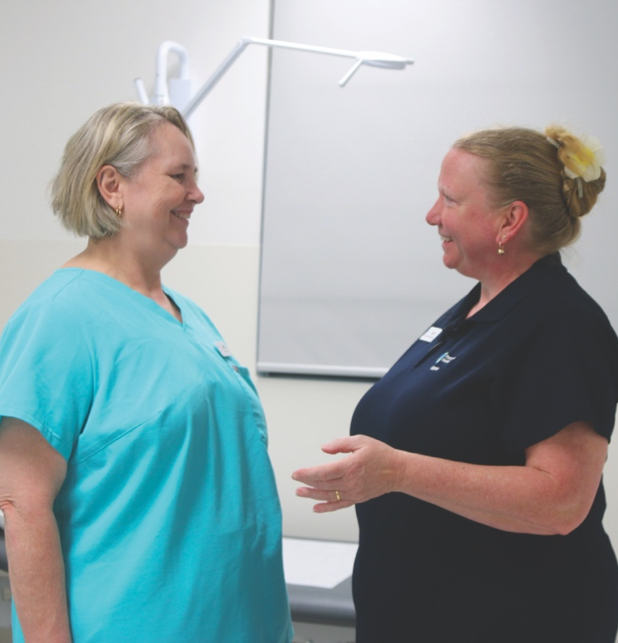
Our Workforce
Peninsula Health employs 7,655 highly skilled and dedicated staff members who work together to provide safe, personal, effective, and connected care to every person, every time.
We are committed to our vision of providing outstanding health and community care, delivering our best with dignity and respect. We continuously strive for excellence in everything we do, ensuring we meet the needs of our community and make a positive impact on their health and wellbeing.
All employment and conduct principles have been correctly applied, and all employees have been correctly classified in workforce data collections.

Peninsula Health Employees 2024–25
Hospitals labour category | June Current Month FTE* |  | Average Monthly FTE*
 | 2024 | 2025 | 2024 | 2025
Nursing | 2,205.84 | 2,188.29 | 2,175.58 | 2,177.30
Administration and Clerical | 717.50 | 738.52 | 720.13 | 735.60
Medical Support | 796.50 | 824.08 | 760.38 | 820.62
Hotel and Allied Services | 380.18 | 372.26 | 383.48 | 370.74
Medical Officers | 62.22 | 59.94 | 58.31 | 60.28
Hospital Medical Officers | 437.29 | 442.55 | 423.71 | 436.55
Sessional Clinicians | 151.9 | 161.11 | 145.85 | 156.19
Ancillary Staff (Allied Health) | 195.3 | 203.77 | 193.43 | 201.23
Total | 4,946.73 | 4,990.53 | 4,860.87 | 4,958.51
* The FTE figures in this table exclude overtime. They do not include contracted staff, i.e. agency nurses or fee-for-service Visiting Medical Officers who are not regarded as employees for this purpose.

Occupational Health and Safety
At Peninsula Health, we prioritise the health and safety of our workforce as a foundation for the delivery of care to our clients. Our commitment to fostering a psychologically and physically safe workplace continues to be strengthened through structured and proactive approaches implemented and overseen by the Health, Safety and Wellbeing Team.
A key focus continues to be on ensuring accountability and striving for continuous improvement, which is supported through the ongoing monitoring of key performance indicators such as lost-time injury frequency rates (LTIFR), manual handling incidents, psychological hazards, bullying and sexual harassment complaints, which are regularly reported to the Board.
We also continue to focus on early hazard identification and preventative improvements related to the key focus areas of slips, trips, and falls; hazardous manual handling; psychosocial safety; and occupational violence and aggression (OVA). To support these priorities, targeted programs and campaigns related to the following areas have been developed and/or strengthened:
- External Environmental Inspection Tool: This tool has been developed and is currently being trialled to proactively identify and manage external environmental hazards. The aim of this tool is to reduce incidents, improve safety awareness, and support a culture of compliance and continuous improvement.
- Consultation and Communication: Safety governance has been improved via streamlined hazard escalation from Local Committees to the Employee Safety and Wellbeing Committee, which has authority to make decisions and changes to practice, policy and guidelines. Also, safety documentation has been simplified including an updated Workplace Health and Safety Policy.
- Job Task Analysis: Analyses have been conducted on a range of key operational roles across the organisation to identify physical and psychosocial risks; to support injury prevention, rehabilitation, risk mitigation and strategies; and to improve safety outcomes.
- Manual Handling Operational Plan: Updated resources have been delivered to address identified gaps in employee guidance materials. Our manual handling education has been revitalised through new eLearning modules and practical patient-handling sessions. There have been improvements in incident investigations and we have worked to reinforce the importance of Dynamic Risk Assessments. A train-the-trainer initiative is being considered to empower local leads in promoting safe practices. The program is also working to align with falls prevention efforts, with joint risk assessments planned to address overlapping hazards.
- Psychosocial Safety: Psychological safety has been enhanced through updated policies, improved Employee Assistance Program services, manager training, tools to manage psychosocial risks, and streamlining of OHS procedures. The Respect@PH promotion continues, which specifically targets the prevention and safe reporting of sexual harassment in the workplace.
- Towards Zero Campaign: The goal of this campaign was to reduce OVA incidents and WorkCover claims by raising awareness, building workforce capability, and embedding safety practices.
- RiSCE Local Lead Framework: 60 RiSCE Local Leads have been trained to deliver scenario-based safety education focuses on the message: ‘Stop, Assess, Plan, Learn’. Leads will also act as consultants on policies and education modules to enhance staff safety across the organisation.
- OVA Action Plan: This plan incorporates the recommendations of an external review, including policy consolidation, an OVA assessment tool, and improved risk register processes. Progress is monitored by the Occupational Violence Steering Committee.
Peninsula Health champions a culture of safety and wellbeing. We are continually evolving our programs and practices to empower our workforce and deliver exceptional care.
In 2024–25, the rise in reported workplace hazards reflects a more proactive and mature approach to risk management, with this shift likely to have contributed to a reduction in lost-time WorkCover claims compared to the previous year. Proactive hazard identification audits have allowed for the swift pinpointing of a large number of hazards, the majority of which were promptly rectified, reducing the risk of falls and injuries to patients, visitors and staff. The program is being rolled out across all sites, and the success of the audits is reflected in the table below.

Occupational Health and Safety Data
Occupational Health and Safety Statistics | 2022-23 | 2023-24 | 2024-25
The number of reported hazards/incidents for the year per 100 FTE | 35 | 40 | 46.7
The number of ‘lost-time’ standard WorkCover claims for the year per 100 FTE | 1.36 | 1.28 | 1.08
The average cost per WorkCover claim for the year | $116,826 | $123,102 | $82,579

Occupational Violence
The organisation maintains a strong culture of reporting hazards and incidents in relation to occupational violence and aggression (OVA). This sustained reporting is supported by ongoing staff awareness initiatives and encouragement to proactively raise health and safety concerns.
Peninsula Health continues to strengthen its commitment to preventing and managing OVA through the OVA Action Plan 2023–2025. The plan continues to drive improvements in staff education and training, incident reporting and analysis, and governance through policy review and updates.
The launch of the ‘Towards Zero – Reducing the Impact of Occupational Violence Campaign’ in 2024 further reinforced key safety messages and empowered staff to prioritise their own safety while fostering a safer workplace for all. Proactive prevention and risk-mitigation strategies have contributed to a reduction in the proportion of OVA incidents resulting in physical injury compared with the previous year.

Occupational Violence Statistics
Occupational violence statistics | 2024-25
WorkCover accepted claims with an occupational violence cause per 100 FTE | 0.32
Number of accepted WorkCover claims with lost-time injury with an occupational violence cause per 1,000,000 hours worked | 1.57
Number of occupational violence incidents reported | 1,135
Number of occupational violence incidents reported per 100 FTE | 22.87
Percentage of occupational violence incidents resulting in a staff injury, illness or condition | 25.6%

Definitions
For the purposes of the statistics on the opposite page, the following definitions apply:
- ‘occupational violence’ is any incident where an employee is abused, threatened or assaulted in circumstances arising out of, or in the course of, their employment.
- an ‘incident’ is an event or circumstance that could have resulted in, or did result in, harm to an employee; incidents of all severity rating must be included. (Code Grey reporting is not included; however, if an incident occurs during the course of a planned or unplanned Code Grey, the incident must be included)
- ‘accepted WorkCover claims’ are accepted claims lodged in 2024–25
- ‘lost-time’ is defined as greater than one day
- ‘injury, illness or condition’ include all reported harm as a result of the incident, regardless of whether the employee required time off work or submitted a claim.

General Information

Equal Opportunity and Code of Conduct
To further embed a values-driven culture across the organisation, 154 leaders participated in the Values Based Leadership program in 2024–25. Of those participants, 94 per cent agreed the session provided them with the knowledge to be a values-based leader, and 95 per cent agreed it supported them in identifying ways to embed Peninsula Health’s values within their teams. Reflecting the growing engagement with our values, we saw a 21 per cent increase in Values Award nominations, rising from 730 in 2023–2024 to 884 in 2024–25. Additionally, 1,030 virtual thank you cards were issued between July 2024 and June 2025, compared to 788 in the prior financial year, indicating a continued uplift in peer recognition and appreciation across the organisation.

Building Act 1993 (Vic)
The Minister for Finance has issued instructions in accordance with the Building Act 1993 (Vic). All public entities are required to ensure that all buildings under their control are safe and fit for occupation, comply with statutory requirements, buildings are maintained to a standard in which they remain safe and fit for occupancy, and to report annually on measures taken to ensure compliance with the Building Act 1993 (Vic).
It is Peninsula Health’s practice to obtain building permits for new construction and significant alterations, and to obtain Certificates of Occupancy or Certificates of Final Inspection as required upon completion. All new building works involve appropriately registered building practitioners in accordance with the Building Regulations 2018 (Vic).
Routine inspections, including Essential Safety Measures (ESM) audits and statutory maintenance, are undertaken in accordance with relevant Australian Standards and regulatory obligations. These inspections are overseen by the Peninsula Health and, where required, the highest priority recommendations arising from these inspections are addressed through planned rectification works. This ensures buildings remain safe, compliant, and fit for clinical and operational use.

Carers Recognition Act 2012 (Vic)
Peninsula Health has taken all practical measures to comply with its obligations under the Carers Recognition Act 2012 (Vic). These include:
- promoting the principles of the Act to people in care relationships who receive our services and to the wider community by providing links to state government resource materials on our website
- ensuring our staff have an awareness and understanding of the care relationship principles through offering induction and training programs based on care principles
- considering the care relationships principles set out in the Act when setting policies and providing services, including employment policies such as flexible working arrangements, staff leave policies, and patient-led and carer-led escalation guidelines
- implementing priority actions in recognising and supporting Victoria’s carers: Victorian carer strategy 2018–2022, including continuation of the Carer Support Fund for Mental Health carers experiencing financial hardship, and formation of the carer support groups in Community Health.

National Competition Policy
Peninsula Health takes all practicable measures to ensure compliance with the National Competition Policy and Victoria’s Competitive Neutrality Policy. Measures include:
- requirement for staff to declare conflicts of interest
- compliance with HealthShare Victoria’s probity policies
- probity principles embedded in procurement.

Public Interest Disclosures Act 2012
Peninsula Health has policies and procedures for receiving complaints and notifications of public sector improper conduct and corrupt conduct, which comply with the Public Interest Disclosures Act 2012 (Vic).
The Peninsula Health Public Interest Disclosure Coordinator is responsible for managing the health and wellbeing of any person who makes a Protected Disclosure, including protection from detrimental action. Peninsula Health’s Protected Disclosure policy informs employees of their right to report suspected improper and/or corrupt conduct directly to the Independent Broad-based Anti-Corruption Commission (IBAC). In 2024–25, there were no disclosures notified to the IBAC.

Safe Patient Care Act 2015
Peninsula Health has no matters to report in relation to its obligations pursuant to section 40 of the Safe Patient Care (Nurse to Patient and Midwife to Patient Ratios) Act 2025 (Vic).

Contracts

Local Jobs First Act 2003 (Vic)
The Local Jobs First Act 2003 introduced in August 2018, brings together the Victorian Industry Participation Policy (VIPP) and Major Project Skills Guarantee (MPSG) policy, which were previously administered separately.
Departments and public sector bodies are required to apply the Local Jobs First policy in all projects valued at $3 million or more in metropolitan Melbourne or for state-wide projects, or $1 million or more for projects in regional Victoria.
The MPSG applies to all construction projects valued at $20 million or more.
The MPSG guidelines and VIPP guidelines will continue to apply to MPSG-applicable and VIPP-applicable projects respectively where contracts have been entered into prior to 15 August 2018.

Projects commenced – Local Jobs First Standard
During 2024–25, Peninsula Health commenced four Local Jobs First Standard projects, totalling $23.2 million. Of those projects, all four are located in metropolitan Melbourne, with a commitment of 100 per cent of local content. The MPSG does not apply to these projects.
The commitments made as part of the Local Jobs First policy for these projects are as follows:
- 100 per cent of local content commitment was made
- a total of 33 jobs (AEE) were committed, including the creation of 10.39 new jobs and the retention of 22.61 existing jobs (AEE). The breakdowns of jobs per project are below:
- Electronic Patient Flow Management – A total of 1.81 jobs (AEE) were committed, including the creation of 1.41 new jobs and the retention of 0.4 existing jobs (AEE).
- Virtual Server Environment Replacement – A total of 0.37 jobs (AEE) were committed, no new jobs were created and the retention of 0.37 existing jobs (AEE).
- Infant Child and Youth Precinct Project – A total of 28.55 jobs (AEE) were committed, including the creation of 8.52 new jobs and the retention of 20.03 existing jobs (AEE).
- Frankston Public Hospital ICT Network LAN and WLAN – A total of 5.85 jobs (AEE) were committed, including the creation of 2.11 new jobs and the retention of 3.74 existing jobs (AEE).
For projects commenced, the total LIDP commitments (local content, employment and engagement of apprentices, trainees, and cadets) committed as a result of these projects are:
- Electronic Patient Flow Management – Vendor: Alcidion Pty Ltd – A total of 0.5 standard employees were retained.
- Virtual Server Environment Replacement – Vendor: Outcomex Pty Ltd – A total of 0.10 standard employees were retained.
- Infant Child and Youth Precinct Project – Vendor: Alchemy Construct Pty Ltd – A total of 5.68 and 17.03 standard employees were created and retained respectively. A total of 2.84 apprentice positions were created and 2.84 employees were retained. A total of 0.16 cadets were retained.
- Frankston Public Hospital ICT Network LAN and WLAN – Vendor: Outcomex Pty Ltd – A total of 2.11 and 3.74 standard employees were created and retained respectively.
The total number, across all projects commenced or completed by the department, of small and medium sized businesses engaged, as either the principal contractor or as part of the supply chain, is not yet available from by the vendor.

Gender Equality Act 2020
The current Gender Equality Action Plan (GEAP) 2021–2025 is approaching its final phase, with several foundational initiatives underway or completed. These include a review of recruitment policies and processes to identify and remove barriers for diverse applicants, the addition of a ‘Diversity and Inclusivity’ statement in all job advertisements, and the initial rollout of a staged civility campaign, beginning with a focus on respectful language in the workplace. To support equity focused decision-making, Peninsula Health has introduced processes and guidance to help managers determine when an Equity Impact Assessment is required for policies, strategies, and frameworks. Monthly education sessions are being rolled out to build capability and embed this practice across the organisation. Actions still in progress will be carried forward into the next GEAP, which is scheduled for development in 2026. The findings from the forthcoming audit, covering June 2024 to July 2025, will inform the next plan’s priorities and help shape the organisation’s continued journey toward gender equality.

Car Parking Fees
Peninsula Health complies with the relevant hospital circular on car parking fees and details of car parking fees and concession benefits can be viewed on our website https://www.peninsulahealth.org.au/patients-visitors/car-parking-and-transport/frankston-hospital-car-parking-information/

Freedom of Information Annual Report 2024–25

Freedom of Information Act 1982 (Vic) – Part II Statement
In accordance with Part II of the Freedom of Information Act 1982 (Vic) (FOI Act), Peninsula Health is required to publish certain statements in respect of its functions and processes.
Statement 1: Organisation and functions
Peninsula Health is a public health service established under section 65P of the Health Services Act 1988 (Vic). The powers and duties of Peninsula Health are prescribed by the Health Services Act 1988 (Vic). For information about the structure and functions of Peninsula Health, please visit the Peninsula Health website at https://www.peninsulahealth.org.au/ and refer to the following links:
- About
- Our Board
- Organisational structure
- Services
- Locations
Statement 2: Categories of documents held by Peninsula Health
Peninsula Health has a wide range of documents that are used by staff in the daily operations of the organisation, which assist with the administration of laws or schemes affecting the public. These include the following types of documents:
- Policies and guidelines
- Employee records
- Financial records
- Medical records
- Commercial documents
- Reports
Statement 3: Publications
The Peninsula Health website contains a wide range of publications available to the public. Please refer to the Publications page on Peninsula Health’s website to access these documents.
Information relating to the application of the FOI Act at Peninsula Health is published in Peninsula Health’s Annual Report. Please refer to the Publications page on Peninsula Health’s website to access these documents. Further information about Peninsula Health’s FOI activities is published in the Office of the Victorian Information Commissioner’s (OVIC) Annual Reports. This report can be accessed at Annual reports - Office of the Victorian Information Commissioner (ovic.vic.gov.au).
Statement 4: Subscriptions and mailing lists
Peninsula Health offers the community free access to our newsletter. To subscribe, please visit our Publications page on Peninsula Health’s website to subscribe to our newsletter.
Members of the public who would like to donate to Peninsula Health or subscribe to the donor mailing list will find additional information about supporting Peninsula Health on our website on the Peninsula Health Support us / Donate page.

Statement 5: Freedom of Information arrangements
The Privacy and Information Release Unit (PIRU) is responsible for processing freedom of information (FOI) requests at Peninsula Health. Contact details for this unit are listed under the ‘All other information and privacy requests, including Freedom of Information requests’ within the Information Release section of Peninsula Health’s website (https://www.peninsulahealth.org.au/patients-visitors/information-release/).
Peninsula Health’s FOI Officers can be contacted via email on PIRU@phcn.vic.gov.au or by calling (03) 9784 7748. All requests for access to documents under the provisions of the FOI Act must be made in writing, and include sufficient information about that document to enable it to be identified and be accompanied by the prescribed, non-refundable application fee. As of 1 July 2025, the FOI application fee is $33.60 for all FOI requests. People suffering financial hardship may apply to have the application fee reduced or waived.
The Department of Treasury and Finance index fee units each year. The fee units and charges applied by Peninsula Health under the FOI Act and associated Regulations are set in line with these requirements. Further information about the current FOI costs charged by Peninsula Health are detailed on the application form.
For additional information regarding accessing your medical records please see the ‘How do I Access my Peninsula Health Medical Record’ under the My Health Information – Frequently Asked Questions (FAQ) within the Information Release section of Peninsula Health’s website.
Summary of the application and operation of the FOI Act
During the 1 July 2024 - 30 June 2025 reporting period, PIRU received 15,860 requests for information, 1207 of which were processed under FOI, as follows:
Number | Outcome
880 | Access granted in full
28 | Access granted in part
3 | Access denied in full
17 | Withdrawn
1 | Not proceeded with
25 | No documents exist
32 | Not finalised as of 30 June 2025
4 | Section 39 amendment requests
217 | Processed outside the FOI Act

As required by the FOI Act and Professional Standards, we are required to process requests for information informally, at the lowest reasonable cost, and outside the FOI Act wherever possible and as permitted by law. As identified above, we processed 1207 of the 15,860 requests under the FOI Act. 92.4 per cent of all requests were processed outside the FOI Act at no charge to the requestor.
Of the 1024 valid FOI applications, 646 were personal, meaning that these were made by the individual (or their legal representative) for personal information about themselves. The requestors who make non-personal requests vary, but are predominantly insurers, agents acting for insurers, or lawyers acting for insurers.

Consultancies Information

Details of consultancies (under $10,000)
In 2024–25, there were five consultancies where the total fees payable to the consultants were less than $10,000. The total expenditure incurred during 2024–25 in relation to these consultancies was $15,060 (excl. GST).

Details of consultancies (valued at $10,000 or greater)
In 2024–25, there were two consultancies where the total fees payable to the consultants were $10,000 or greater. The total expenditure incurred during 2024-25 in relation to these consultancies was $149,551 (excl. GST).

Consultancies of $10,000 or greater:
Consultant | Purpose of consultancy | Start date | End date | Total approved project fee  (excL. GST) | Expenditure 2024–25  (excL. GST) | Future expenditure  (excL. GST)
Nous Group  Pty Ltd | Review and advice in relation to Peninsula Health's home care program services | 30 May  2025 | 8 August 2025 | $192,600 | $127,300 | $65,300
Urbis | Specialist design and planning advice | 16 July  2024 | 29 April  2025 | $22,251 | $22,251 | $0
TOTAL |  |  |  |  | $149,551 | $65,300

Information and Communication Technology (ICT) expenditure
The total ICT expenditure incurred during 2024–25 was $25,801,385 (excluding GST), with the details shown below.

ICT expenditure
Business As Usual  (BAU) ICT expenditure | Non Business As Usual (non BAU) ICT expenditure
(Total)  (excl. GST) | (Total = Operational expenditure and Capital expenditure)  (excl. GST) | Operational expenditure  (excl. GST) | Capital expenditure  (excl. GST)
$15,538,771 | $10,262,614 | $1,785,743 | $8,476,870

Environmental Performance and strategic aims
Peninsula Health is committed to reducing its environmental impact while continuing to delivering high-quality health care. A summary of the Environmental Management Plan is available on our website. Peninsula Health is committed to reducing its greenhouse gas emissions in line with the Victorian Government’s targets to achieve net-zero by 2045. Peninsula Health aims to address the impacts of climate change and reduce the health service’s reliance on natural resources. With the support of Climate Health Victoria, Peninsula Health will develop an Emissions Reduction Plan to minimise its reliance on natural gas.

Frankston Hospital redevelopment
This project will be a model of environmental sustainability; delivering:
- an all-electric energy solution for the new tower, resulting in carbon neutral power use
- an innovative energy-saving technology (generating more than 800kVA from solar panels) while preserving water, resources, and energy
- a mechanical system will create 100 per cent fresh air throughout the new tower building
- secure bicycle parking with end-of-trip facilities to support active travel
- electric vehicle charging points in the new P1 multi-deck car park for staff, visitors and fleet cars.

Sustainable initiatives

Solar
Funded by the Victorian Health Building Authority, Peninsula Health installed two new solar panel systems at The Mornington Centre and Golf Links Road Rehabilitation Centre, to cut energy use and reduce carbon emissions.

Fleet Vehicles
Peninsula Health has incorporated hybrid vehicles into its fleet since 2016, and as of March 2025, 83 per cent of fleet cars are hybrid vehicles. Planning is underway to incorporate electric vehicles (ZEVs) into the Peninsula Health fleet. This initiative aligns with the Victorian Government’s commitment to transition the government motor vehicle fleet to ZEVs by 2035.

Blister Pack Program
Peninsula Health has partnered with Pharmacycle to stop blister packs ending up in landfill. Pharmacycle distributes recovered material to local manufacturers for use. As of June 2025, 258,000 blister packs have been collected, which has created 330kg of plastic and 57kg of aluminium for recycling.

Peninsula Health NABERS Results
The National Australian Built Environment Rating System (NABERS) for energy and water at public hospitals, rates the efficiency and environmental impact of entire hospital campuses. The ratings are based on actual operational data over a 12-month period. Unlike other NABERS ratings, NABERS for public hospitals operates through a direct relationship with state health departments in partnership with the Australasian Health Infrastructure Alliance (AHIA), rather than via third-party assessors. Ratings are conducted by trained assessors within health departments, which are then certified and audited by NABERS.

The Peninsula Health NABERS results for 2025:
Site | Address | Energy Star Ratings (without GreenPower) | Water Star Ratings
Frankston Hospital | 2 Hastings Road, Frankston 3199 | 5 | 5
Golf Links Road Rehabilitation Centre | 125 Golf Links Road, Frankston 3199 | 3.5 | 5.5
The Mornington Centre | 24 Separation Street, Mornington 3931 | 4.5 | 5.5
Rosebud Hospital | 1527 Point Nepean Road, Rosebud 3199 | 6 | 5.5

Environmental Report
Electricity Use | 2024-25 | 2023-24 | 2022-23
EL1 Total electricity consumption segmented by source [MWh]
Purchased | 20,322.72 | 20,121.18 | 19,652.56
Self-generated | 31.34 | 42.45 | 30.42
EL1 Total electricity consumption [MWh] | 20,354.07 | 20,163.63 | 19,682.98
EL2 On-site electricity generated [MWh] segmented by
Consumption behind-the-meter  Solar electricity | 31.34 | 42.45 | 30.42
Total consumption behind-the-meter [MWh] | 31.34 | 42.45 | 30.42
EL2 Total On-site electricity generated [MWh] | 31.34 | 42.45 | 30.42
EL3 On-site installed generation capacity [kW converted to MW] segmented by
Diesel generator | 14.56 | 14.56 | 14.56
Solar Energy Catchment | 0.19 | 0.19 | 0.03
EL3 Total on-site installed generation  capacity [MW] | 14.75 | 14.75 | 14.59
EL4 Total electricity offsets segmented by offset type [MWh]
RPP (Renewable Power Percentage in the grid) | 3,720.91 | 3,774.59 | 3,694.68
EL4 Total electricity offsets [MWh] | 3,720.91 | 3,774.59 | 3,394.68

Stationary Energy |  | 2024-25 |  | 2023-24 |  | 2022-23
F1 Total fuels used in buildings and machinery segmented by fuel type [MJ]
Natural gas | 70,222,218.50 |  | 69,335,426.80 |  | 77,595,886.40
Diesel | 171,577.00 |  | 128,731.00 |  | 212,323.00
F1 Total fuels used in buildings [MJ] | 70,393,795.50 |  | 69,464,157.80 |  | 77,808,209.40
F2 Greenhouse gas emissions from stationary fuel consumption segmented by fuel type
[Tonnes CO2-e]
Natural gas | 3,618.55 |  | 3,572.85 |  | 3,998.52
Diesel | 12.04 |  | 9.04 |  | 14.90
F2 Greenhouse gas emissions from stationary fuel consumption [Tonnes CO2-e] | 3,630.60 |  | 3,581.89 |  | 4,013.42

Transportation Energy | 2024-25 | 2023-24 | 2022-23
T1 Total energy used in transportation (vehicle fleet) within the Entity, segmented by fuel type [MJ]
Non-executive fleet – Gasoline | 3,741,558.70 | 3,750,813.10 | 3,577,891.10
Petrol | 3,741,558.70 | 3,750,813.10 | 3,577,891.10
Non-executive fleet – E10 | 26,058.80 | 19,938.20 | 12,900.20
Petrol (E10) | 26,058.80 | 19,938.20 | 12,900.20
Non-executive fleet – Diesel | 1,497,703.10 | 1,303,317.40 | 1,281,925.30
Diesel | 1,497,703.10 | 1,303,317.40 | 1,281,925.30
Total energy used in transportation  (vehicle fleet) [MJ] | 5,265,320.60 | 5,074,068.70 | 4,872,716.60
T3 Greenhouse gas emissions from transportation (vehicle fleet) segmented by fuel type
[tonnes CO2-e]
Non-executive fleet – Gasoline | 253.00 | 253.63 | 241.94
Petrol | 253.00 | 241.94 | 241.94
Non-executive fleet – E10 | 1.59 | 1.21 | 0.79
Petrol (E10) | 1.59 | 1.21 | 0.79
Non-executive fleet – Diesel | 105.45 | 91.77 | 90.26
Diesel | 105.45 | 91.77 | 90.26
Total greenhouse gas emissions from transportation (vehicle fleet) [tonnes CO2-e] | 360.04 | 346.61 | 332.98
T4 Total distance travelled by commercial air travel (passenger km travelled for business purposes
by entity staff on commercial or charter aircraft)
Total distance travelled by commercial air travel | 116,411.90 | 207,069.00

Total Energy Use | 2024-25 | 2023-24 | 2022-23
E1 Total energy usage from fuels, including stationary fuels (F1) and transport fuels (T1) [MJ]
Total energy usage from stationary fuels (F1) [MJ] | 70,393,795.50 | 69,464,157.80 | 77,808,209.40
Total energy usage from transport fuels (T1) [MJ] | 5,265,320.60 | 5,074,068.70 | 4,872,716.60
Total energy usage from fuels, including stationary fuels (F1) and transport fuels (T1) [MJ] | 75,659,116.10 | 74,538,226.50 | 82,680,926.00
E2 Total energy usage from electricity [MJ]
Total energy usage from electricity [MJ] | 73,274,645.01 | 72,589,061.71 | 70,858,738.19
E3 Total energy usage segmented by renewable and non-renewable sources [MJ]
Renewable | 13,510,710.37 | 13,743,336.77 | 13,411,660.94
Non-renewable (E1 + E2 - E3 Renewable) | 135,423,050.74 | 133,383,951.44 | 140,128,003.25
E4 Units of Stationary Energy used normalised
Energy per unit of Aged Care OBD  [MJ/Aged Care OBD] | N/A* | N/A* | 28,889.81
Energy per unit of LOS [MJ/LOS] | 510.59 | 486.69 | 518.55
Energy per unit of bed-day (LOS+Aged Care OBD) [MJ/OBD] | 510.59 | 486.69 | 509.41
Energy per unit of Separations [MJ/Separations] | 1,419.21 | 1,421.98 | 1,593.27
Energy per unit of floor space [MJ/m2] | 1,560.31 | 1,542.77 | 1,614.59

Water Use | 2024-25 | 2023-24 | 2022-23
W1 Total units of metered water consumed by water source (kL)
Potable water [kL] | 123,635.00 | 113,272.65 | 97,971.43
Reused water [kL] | 3,337.90 | 8,542.45 | 10,436.73
Total units of water consumed [kL] | 126,972.90 | 121,815.09 | 108,408.16
W2 Units of metered water consumed normalised by FTE, headcount, floor area, or other entity or sector specific quantity
Water per unit of Aged Care OBD  [kL/Aged Care OBD] | N/A* | N/A* | 21.07
Water per unit of LOS [kL/LOS] | 0.45 | 0.42 | 0.38
Water per unit of bed-day (LOS+Aged Care OBD) [kL/OBD] | 0.45 | 0.42 | 0.37
Water per unit of Separations [kL/Separations] | 1.25 | 1.22 | 1.16
Water per unit of floor space [kL/m2] | 1.38 | 1.32 | 1.18

Waste And Recycling | 2024-25 | 2023-24 | 2022-23
WR1 Total units of waste disposed of by waste stream and disposal method [kg]
Landfill (total)
General waste – bins | 305,402.05 | 306,330.09 | 397,428.05
General waste – compactors | 493,147.93 | 494,470.00 | 417,120.00
General waste – skips | 106,884.16 | 190,194.50 | 111,058.40
Offsite treatment
Clinical waste – incinerated | 9,446.09 | 9,469.15 | 10,210.69
Clinical waste – sharps | 20,846.81 | 20,934.12 | 19,171.18
Clinical waste – treated | 120,875.22 | 121,730.35 | 62,771.69

Waste And Recycling | 2024-25 | 2023-24 | 2022-23
Recycling/recovery (disposal)
Batteries | 460 | 178 | 173
Blister packs | 387.55 | 79.21 | N/A*
Cardboard | 492,024.78 | 492,237.38 | 199,744.23
Commingled | 95.04 | 95.04 | 148,881.92
E-waste | 7,610 | 8,311 | 9,241
Fluorescent tubes | 102 | 297 | 237
Mattresses | 1,567.75 | 19.05 | N/A*
Organics (food) | 19,560.34 | 19,620 | 34,019
Other recycling | 696.96 | 849.42 | N/A*
Paper (confidential) | 130,659.77 | 131,461.52 | 132,838.21
Paper (recycling) | 1,600.73 | 1,605.12 | 7,923.46
PVC | 136 | 705 | 76
Sterilisation wraps | 715 | 330 | 167
Toner & print cartridges | 257.12 | 85.56 | 380
Total units of waste disposed [kg] | 1,712,475.31 | 1,799,001.51 | 1,551,440.84
WR1 Total units of waste disposed of by waste stream and disposal method [%]
Landfill (total)
General waste | 52.87% | 55.09% | 59.66%
Offsite treatment
Clinical waste – incinerated | 0.55% | 0.53% | 0.66%
Clinical waste – sharps | 1.22% | 1.16% | 1.24%
Clinical waste – treated | 7.06% | 6.77% | 4.05%

Waste And Recycling | 2024-25 | 2023-24 | 2022-23
Recycling/recovery (disposal)
Batteries | 0.03% | 0.01% | 0.01%
Blister packs | 0.02% | 0% | N/A*
Cardboard | 28.73% | 27.36% | 12.87%
Commingled | 0.01% | 0.01% | 9.6%
E-waste | 0.44% | 0.46% | 0.6%
Fluorescent tubes | 0.01% | 0.02% | 0.02%
Organics (food) | 1.14% | 1.09% | 2.19%
Other recycling | 0.04% | 0.05% | N/A*
Paper (confidential) | 7.63% | 7.31% | 8.56%
Paper (recycling) | 0.09% | 0.09% | 0.51%
PVC | 0.01% | 0.04% | 0%
Sterilisation wraps | 0.04% | 0.02% | 0.01%
Toner & print cartridges | 0.02% | 0% | 0.02%
WR3 Total units of waste disposed normalised by FTE, headcount, floor area, or other entity or sector specific quantity, by disposal method
Total waste to landfill per patient treated  (kg general waste)/PPT | 1.88 | 2.02 | 1.92
Total waste to offsite treatment per patient treated (kg offsite treatment)/PPT | 0.31 | 0.31 | 0.19
Total waste recycled and reused per patient treated (kg recycled and reused)/PPT | 1.36 | 1.34 | 1.10
WR4 Recycling rate [%]
Weight of recyclable and organic materials [kg] | 655,873.06 | 655,873.29 | 533,680.82
Weight of total waste [kg] | 1,712,475.31 | 1,799,001.51 | 1,551,440.84
Recycling rate [%] | 38.3% | 36.46% | 34.4%
WR5 Greenhouse gas emissions associated with waste disposal [tonnes CO2-e]
Tonnes CO2-e | 1,369.61 | 1,482.08 | 1,318.79

Greenhouse Gas Emissions | 2024-25 | 2023-24 | 2022-23
G1 Total scope one (direct) greenhouse gas emissions [tonnes CO2e]
Carbon Dioxide | 3,979.87 | 3,917.96 | 4,334.81
Methane | 7.13 | 7.04 | 7.87
Nitrous Oxide | 3.64 | 3.51 | 3.73
Total | 3,990.64 | 3,928.50 | 4,346.40
GHG emissions from stationary fuel (F2) [tonnes CO2-e] | 3,630.60 | 3,581.89 | 4,013.42
GHG emissions from vehicle fleet (T3) [tonnes CO2-e] | 360.04 | 346.61 | 332.98
Medical/Refrigerant gases
Nitrous oxide | 1,110.28 | 919.07 | 420.14
Refrigerant – R134A | 822.04 | 698.46 | 698.46
Refrigerant – R22 | 62.57 | 99.21 | 132.18
Refrigerant – R401A (MP39) | 8.71 | 8.16 | 8.16
Refrigerant – R402A (HP80) | 6.87 | 6.41 | 6.41
Refrigerant – R404A | 20.66 | 17.23 | 16.32
Refrigerant – R407A | 22.53 | 20.99 | 20.99
Refrigerant – R407C | 20.68 | 19.23 | N/A*
Refrigerant – R410A | 98.99 | 110.32 | 109.28
Total scope one (direct) greenhouse gas emissions [tonnes CO2e] | 6,165.27 | 5,831,81 | 5,758.34
G2 Total scope two (indirect electricity) greenhouse gas emissions [tonnes CO2e]
Electricity | 13,411.73 | 13,234.10 | 13,500.37
Total scope two (indirect electricity) greenhouse gas emissions [tonnes CO2e] | 13,411.73 | 13,234.10 | 13,500.37

Greenhouse Gas Emissions | 2024-25 | 2023-24 | 2022-23
G3 Total scope three (other indirect) greenhouse gas emissions associated with commercial air travel and waste disposal [tonnes CO2e]
Commercial air travel | 23.34 | 40.93 | N/A
Waste emissions | 1,369.61 | 1,482.08 | 1,318.79
Indirect emissions from Stationary Energy | 2,105.20 | 1,913.41 | 2,053.47
Indirect emissions from Transport Energy | 144.01 | 128.30 | 83.78
Water emissions | 202.23 | 190.08 | 165.95
Total scope three greenhouse gas emissions  [tonnes CO2e] | 3,814.39 | 3,754.81 | 3,621.99
G(Opt) Net greenhouse gas emissions [tonnes CO2e]
Gross greenhouse gas emissions (G1 + G2 + G3) [tonnes CO2e] | 23,391.38 | 22,820.71 | 22,880.70
Total gross reported greenhouse gas emissions per bed day (CO2-e(t)/OBD) | 0.08 | 0.08 | 0.08
Net greenhouse gas emissions [tonnes CO2e] | 23,391.38 | 22,820.71 | 22,880.70

Normalisation Factors | 2024-25 | 2023-24 | 2022-23
Aged Care OBD | N/A* | N/A* | 5,146.00
ED Departures | 99,233.00 | 98,492.00 | 99,168.00
FTE | 4,793.00 | 4,706.00 | 4,573.00
LOS | 281,375.00 | 291,878.00 | 286,698.00
OBD | 281,375.00 | 291,878.00 | 291,844.00
PPT | 481,839.00 | 490,268.00 | 483,304.00
Separations | 101,231.00 | 99,898.00 | 93,292.00
TotalAreaM2 | 92,077.00 | 92,077.00 | 92,077.00
Indicators are not reported where data is unavailable or an indicator is not relevant to the organisation’s operations. CO2 emission totals vary year on year due to calculation tool enhancement.

Social Procurement Framework
Peninsula Health engaged nine social enterprises, with a total expenditure of $2,502,006.52, and partnered with three Victorian Aboriginal businesses, recording a total expenditure of $11,943.90. Peninsula Health intends to progressively increase its commitment to the Social Procurement Framework objectives, driving both social and economic impact by supporting local enterprises and Aboriginal businesses. During 2025–2026, Peninsula Health will look to increase engagement with these key sectors.
2024–25 SOCIAL PROCUREMENT FRAMEWORK REPORTING
SPF Objective | Outcome | Metric | Unit of Measure | 2024-25 Actual
Sustainable Victorian social enterprises and Aboriginal business sectors | Purchasing from Victorian social enterprises and Aboriginal businesses | Number of Victorian social enterprises engaged | 9
 |  | Number of Victorian Aboriginal businesses engaged | 3
 |  | Number of Victorian social enterprises led by a mission for job readiness and employment of Victorian Priority Jobseekers | 1
 |  | Number of Victorian social enterprises led by a mission for people with disability and Australian disability enterprise. | 2
 |  | Total expenditure with Victorian social enterprises (excl. GST) | 33 invoices | $2,495,605.12
 |  | Total expenditure with Victorian Aboriginal businesses (excl. GST) | 8 invoices | $11,943.90
 |  | Total expenditure with Victorian social enterprises led by a mission for people with disability and Australian disability enterprise. | 2 invoices | $3,067.50
 |  | Total expenditure with Victorian social enterprises led by a mission for job readiness and employment of Victorian Priority Jobseekers | 2 invoices | $1,351.00

Additional information available on request
Details in respect of the items listed below have been retained by the health service and are available to the relevant Ministers, Members of Parliament and the public on request (subject to freedom of information requirements, if applicable):
- a statement that declarations of pecuniary interests have been duly completed by all relevant officers;
- details of shares held by a senior officer as nominee or held beneficially in a statutory authority or subsidiary;
- details of publications produced by the entity about itself, and how these can be obtained;
- details of changes in prices, fees, charges, rates, and levies charged by the health service;
- details of any major external reviews carried out on the health service;
- details of major research and development activities undertaken by the health service
- details of overseas visits undertaken, including a summary of the objectives and outcomes of each visit;
- details of major promotional, public relations, and marketing activities undertaken by the health service to develop community awareness of the health service and its services
- details of assessments and measures undertaken to improve the occupational health and safety of employees
- a general statement on industrial relations within the health service and details of time lost through industrial accidents and disputes
- a list of major committees sponsored by the health service, the purposes of each committee, and the extent to which the purposes have been achieved
- details of all consultancies and contractors including:
- consultants/contractors engaged
- services provided
- expenditure committed for each engagement.
This information is available on request from:
Chief Communications Officer
Peninsula Health
Phone: (03) 9784 7777
email: corporate.relations@phcn.vic.gov.au

Thank you to our supporters
During the 12-month period to 30 June 2025, Peninsula Health was supported by a number of local people, community groups, estates, trusts, foundations and businesses.
Due to their generosity in donations, we were able to support a number of key areas across the health service including:
Maternity Services | The Mornington Centre | Urology
Emergency Services | Oncology Services | Education and Training
Intensive Care Unit | Palliative Care | Rehabilitation
Mental Health | Research
The Learning Hub | Cardiology

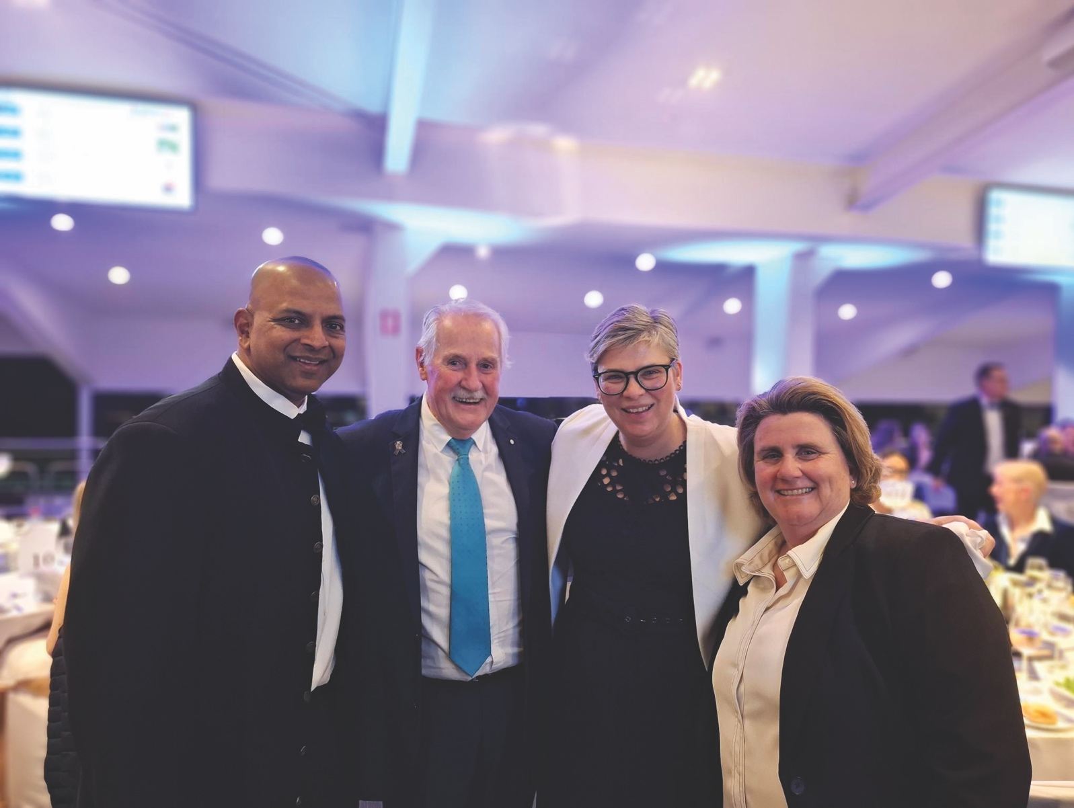

Peninsula Health is very appreciative of the generous financial support received from individuals, businesses, trusts, foundations, community groups and other organisations. We are delighted to acknowledge these significant contributions below.
Individuals: | Businesses, trusts and community groups: | Businesses, trusts and community groups:
Marjorie Armitage | Allison Monkhouse | Quest Frankston on the Bay
Joseph Attard | The Andrews Foundaton | Ritchies Store Pty Ltd
Joyce Beckwith | Are Media/Bounty | Rosebud Heart Soccer Club
Pat Boag | Australian Croatian Social Club | Rosebud Hospital Kiosk  Auxiliary
Bruce Boell | Bagôt Gjergja Foundation | Rosebud Hospital Kiosk  Auxiliary
Mervyn & Janet Bullas | Beretta’s Hotel Langwarrin | Rosebud Rock ‘N’ Rods Festival
Normie Bydder | Blue Label Pty Ltd | Rotary Club of Frankston  Peninsula 2.0
E. L. Chapman | Blue Ribbon Foundation | Rotary Club of Frankston  Peninsula 2.0
Sally Cleary | Carrington Park Golf Club  At Eagle Ridge | Rotary Club of Rosebud Rye
Don Clifton | Carrington Park Golf Club  At Eagle Ridge | Rotary Sunrise of Frankston
Nicolae Cojocaru | Collier Charitable Fund | Rotary The Barrel District 982
Stephen Crawford | Country Womens Association  Rosebud Branch | RSL Rosebud Women’s Auxiliary
Gabby Crehan | Country Womens Association  Rosebud Branch | Rye Beach Opp Shop
Geoffrey Delahoy | Estate of Paul Douglas Daniel | Senior Citizens Club Tootgarook
Trevor Edwards | Dromana T.O.W.N. Club | Southern Peninsula Classic
Greg Shalit and  Dr Miriam Faine | Five Loaves Initiative | and Historic Car Club
Greg Shalit and  Dr Miriam Faine | Frankston Hospital  Pink Ladies Auxiliary | Toorak College
Mark Found | Frankston Hospital  Pink Ladies Auxiliary | Turosi Giving
Harry Georgalas | Greenways Residents  Committee | Vic Health
D. L. Glergia | Greenways Residents  Committee | Village Glen Retirement Living
Susan Grant | Humpty Dumpty Foundation | Dr Owen Williams Mental  Health Research Grant
Sue Guthrie | Invocare Australia | Dr Owen Williams Mental  Health Research Grant
Mr Jesper Hansen | Lions Club Dromana
Stephanie Johnston | Lions Club Flinders District
Norman Kaye | Lions Club Mornington Inc
Nathan Kelley | Lions Club Rye
Nicole Khaissi | Martha Cove Village  Singing Group
Brent Loughrey | Martha Cove Village  Singing Group
Ian McBeath | McClelland Secondary College
Brian & Val Moss | Menzies Caring For Kids
Graham Mouser | Munchalots 2
Paul & Sue Neylan | O’Donohue Family  Foundation Trust
Sam Oliveri | O’Donohue Family  Foundation Trust
Enrico Petrosino | PARC Peninsula Leisure Pty Ltd
Elaine Smeaton | Peninsula Boys Car Enthusiasts
Lady Marigold Southey | Martha Cove Village
Malcolm Thompson | Singing Group
Richard Tindale | Peninsula Dealer Group
John Wiegandt | Peninsula Grammar  Parents Association
William Wood | Peninsula Grammar  Parents Association
Byron Woods | Peninsula Health Palliative Care
Two of our volunteer groups continue to raise significant funds for Peninsula Health. Funds raised by The Pink Ladies Auxiliary at Frankston Hospital are helping to fund a professorial role at Frankston Hospital in Nursing and Midwifery research capability and capacity, a joint appointment with Monash University, as well as funding life-saving equipment for the hospital and the local community. The Rosebud Hospital Kiosk has also funded life-saving equipment for our hospital on the southern peninsula and we are particularly grateful to this group of incredible volunteers who give back to the community and our health service in such a remarkable manner.
Peninsula Health joined with the Blue Ribbon Foundation, Peninsula Branch to raise funds to enable the purchase of two ECMO (Extracorporeal Membrane Oxygenation) machines for Peninsula Health, which will enable us to save lives while acknowledging the memory of the fallen officers. The machines will be dedicated to the memory of those officers who lost their lives in the 2020 Eastern Freeway crash: Leading Senior Constable Lynette Taylor, Senior Constable Kevin King, Constable Joshua Prestney and Constable Glen Humphris.

Other Reporting Requirements

Mental Health and Wellbeing Act 2022
The Mental Health and Wellbeing Act 2022 (Vic), which commenced on 1 September 2023, requires all mental health and wellbeing service providers that are required to produce an annual report, to address one or more mental health and wellbeing principles in their annual report. These principles are:
- Mental health and wellbeing services are provided with the least possible restriction of a person’s rights, dignity, and autonomy with the aim of promoting their recovery and full participation in community life.
- The rights, dignity, and autonomy of people living with mental illness or psychological distress are to be promoted and protected.
Peninsula Health is a leader in the reduction of restrictive interventions in Australia. The Mental Health and Wellbeing Service team has continued its sector-leading work in this area, and has eliminated the use of seclusion, whilst maintaining low rates of physical restraints and maintaining staff safety. Peninsula Health is currently engaged in multiple research projects to further evaluate the nature of systems change and culture underlying this success, while supporting the development of further improvements. The Mental Health and Wellbeing Service regularly hosts learning visits from other services across Victoria and the rest of Australia, to provide teaching in how to implement these successes elsewhere.

Key Financial and Service
Performance Reporting

Strategic Priorities
In 2024–25, Peninsula Health contributed to the achievement of the Department of Health’s Strategic Plan 2023-27: Setting out a bold vision for Victorians to be the healthiest people in the world in the below strategic priorities.

Excellence in Clinical Governance
We aim for the best patient experience and care outcomes by assuring safe practice, leadership of safety, an engaged and capable workforce, and continuing to improve and innovate care.

Goals:
- MA2 Strengthen all clinical governance systems, as per the Victorian Clinical Governance Framework, to ensure safe, high-quality care, with a specific focus on building and maintaining a strong safety culture, identifying, reporting, and learning from adverse events, and early, accurate recognition and management of clinical risk to and deterioration of all patients.
- MA6 Improve access to timely emergency care by implementing strategies that improve whole of system patient flow to reduce emergency department wait times and improve ambulance to health service handover times.
- MA7 Improve mental health and wellbeing outcomes by implementing Victoria’s new and expanded Mental Health and Wellbeing system architecture and services.
- MA9 Maintain a commitment to delivering equitable access to planned surgery and drive reform in alignment with the Planned Surgery Reform Blueprint.

Health Service Deliverables:

MA2 Improve paediatric patient outcomes by implementing the ‘ViCTOR track and trigger’ observation chart and escalation system whenever children have observations taken.
Outcome: Complete
The ViCTOR chart use is embedded into everyday practice and incorporated into orientation. ViCTOR charts are in use in all settings where children aged 0–18 years are admitted and require observation. Triggers for escalation in the case of clinical deterioration, are embedded in the ViCTOR charts supporting the provision of safe care for all children. Peninsula Health is participating in a Safer Care for Kids – ViCTOR chart project with Safer Care Victoria. The pilot phase is complete and we are embedding it into practice.

MA6 Adopt models of care that ensure the appropriate skill mix, and senior decision-makers in the right places, to manage the volume of patients and health service demands.
Outcome: Complete
Ambulance offload time has improved and was the best in Victoria for April - June 2025 at Frankston and Rosebud Hospitals. ED Length of stay (LOS) has improved for non-admitted patients, and is consistently close to target. A clinical frailty tool has been implemented and is available for all staff in the electronic health record. A model of care is being developed with the aim to reduce hospital acquired functional decline and reduce LOS. LOS reduction has been associated with the ‘end PJ’ paralysis project.

MA6 Implement initiatives that support early discharge of patients to appropriate settings to improve timely patient access to care.
Outcome: Complete
A collaborative response to complex social presentations to Emergency Departments has resulted in reduction in admissions for non-medical reasons. An increase in NDIS in-reach to Emergency Department clients has supported a reduction in inpatient admissions.

MA7 Engage in one or more mental health improvement program of Safer Care Victoria – elimination of restrictive intervention, improving sexual safety, implementation of the zero suicide framework and reducing compulsory treatment.
Outcome: In progress
The Implementation of Safer Care Victoria’s sexual safety modules on the acute unit and at the Prevention and Recovery Care (PARC) centres is underway. The project commenced to support a reduction of restrictive interventions in the community, in regards to compulsory treatment.

MA9 Implement and scale same-day surgery models of care in line with Safer Care Victoria’s Expanding Day Surgery recommendations.
Outcome: Complete
Day case maximisation continues to progress and is in line with the Health Round Table benchmark of 54 per cent (Apr 2024 - Mar 2025). A frequent observational unit commenced at Frankston Public Surgical Centre (FPSC) to support an increase in acuity and to expand inclusion criteria for the site. It is now standard practice for all default day case procedures that meet criteria, to be scheduled as a day case.

Operate within budget
Ensure prudent and responsible use of available resources to achieve optimum outcomes

Goals:
- MB1 Develop and implement a health service Budget Action Plan (BAP) in partnership with the department to manage cost growth effectively to ensure the efficient operation of the health service.

Health Service Deliverables:

MB1 Deliver on the key initiatives as outlined in the Budget Action Plan.
Outcome: Complete
Peninsula Health agreed a Budget Action Plan (BAP) with the Department of Health to ensure delivery of efficient operation of the health service, which was delivered in full.

MB1 Utilise data analytics and performance metrics to identify areas of inefficiency and waste and make evidence-based decisions to improve financial sustainability and operational performance.
Outcome: Complete
Peninsula Health continues to optimise and produce financial and activity targets that are regularly monitored. We continue to develop our financial tools and models with a new budgeting and forecasting system implemented during the year. A robust risk-management system is in place with regular reviews occurring at all levels, including the Board of Directors.

MB1 Peninsula Health will work closely and openly with HealthShare Victoria (HSV) from a relevant data gathering, relevant data sharing (access to contracts, staffing information, financial), and any other relevant perspective, to ensure timely preparedness for eventual consolidation of their purchasing and supply chain (logistics) functions to HSV.
Outcome: In progress
Discussions have been held with Health Share Victoria (HSV) about different service models. HSV has conducted a data match on the Peninsula Health (PH) catalogue and HSV catalogue. PH is awaiting costing from HSV on various types of services offered by HSV; e.g. loading dock delivery or ward delivery.

Improving equitable access to health care and wellbeing
Ensure that Aboriginal people have access to a health, wellbeing, and care system that is holistic, culturally safe, accessible, and empowering. Ensure that communities in rural and regional areas have equitable health outcomes irrespective of locality.

Goals:
- MC2, MC3 Enhance the provision of appropriate and culturally safe services, programs, and clinical trials for and as determined by Aboriginal people, embedding the principles of self-determination.
- MC4 Expand the delivery of high-quality cultural safety training for all staff to align with the Aboriginal and Torres Strait Islander cultural safety framework. This training should be delivered by independent, expert, community-controlled organisations or a Kinaway or Supply Nation certified Aboriginal business.

Health Service Deliverables:

MC2 Participate in the Aboriginal Health Innovative Initiative in collaboration with SEMHSP to deliver place-based diabetes care in Aboriginal communities.
Outcome: Complete
Place-based diabetes care – including endocrinology, diabetes nurse education, dietetics and podiatry – is being delivered in partnership at First Peoples’ Health and Wellbeing in Frankston. This was established as an ongoing service following a successful trial.

MC4 Implement mandatory cultural safety training and assessment for all staff in alignment with the Aboriginal and Torres Strait Islander cultural safety framework, and developed and/or delivered by independent, expert, and community-controlled organisations, Kinaway or Supply Nation certified Aboriginal businesses.
Outcome: In progress
Training is being developed to meet our requirements, to be available in January 2026. Peninsula Health offers a number of cultural safety training options including cultural immersion and culture awareness training and tours, which are available to all staff and volunteers. This training is extremely well attended and reviewed.

A stronger workforce
There is an increased supply of critical roles, which supports safe, high-quality care. Victoria is a world leader in employee experience, with a focus on future roles, capabilities and professional development. The workforce is regenerative and sustainable, bringing a diversity of skills and experience that reflect the people and communities it serves. As a result of a stronger workforce, Victorians receive the right care at the right time closer to home.

Goals:
- MD1 Improve employee experience across four initial focus areas to assure safe, high-quality care: leadership, health and safety, flexibility, and career development and agility.
- MD2 Explore new and contemporary models of care and practice, including future roles and capabilities.

Health Service Deliverables:

MD1 Undertake gap analysis and implement changes to meet compliance against new psychological safety legislation amendment.
Outcome: In progress
We completed a review of team structure and priorities in supporting the Work Health Safety team to build collaboration and responsiveness. A Work Health Safety committee structure is in place including consultation arrangements and compliance with the Act.

MD2 Continuing to support the implementation of medium and long-term priorities of the Mental Health Workforce Strategy.
Outcome: Complete
A new workforce plan for mental health has been developed and implemented. Attraction and retention strategies are in place and an early in career program is well-established, while career pathways and an evaluation framework are under development. There has been a significant decrease in staffing vacancies within the mental health program.

Moving from competition to collaboration

Share knowledge, information and resources with partner health and wellbeing services and care providers. This will allow patients to experience one health, wellbeing and care system through connected digital health information, evidence and data flows, enabled by advanced interoperable platforms.

Goals:

ME2 Engage in integrated planning and service design approaches while assuring consistent and strong clinical governance with partners to connect the system to deliver seamless and sustainable care pathways and build sector collaboration.

Health Service Deliverables:
- ME2 Undertake planning and design of new EPC at Hastings site in collaboration with VHBA and QEC.
Outcome: Complete
The Subacute service plan is complete. The Early Parenting Centre construction is underway, and is on track for completion in late 2025 or early 2026.

ME2 Reviewing specialist workforce requirements to develop a shared workforce model, including coordinating efforts to attract workforce.
Outcome: Complete
The Mental Health Wellbeing initiative embedded Mental Health and Wellbeing Workers (MHWW) across Peninsula Health to deliver non-clinical, recovery-focused wellbeing support. This complements and enhances the clinical treatment, care and peer support provided by the Mental Health clinical teams. This integrated approach aligns with the Royal Commission into Victoria’s Mental Health System, particularly Recommendation Three, which called for Area Mental Health and Wellbeing Services to be delivered through partnerships between public health services and non-government organisations. The initiative has been an effective strategy for addressing workforce shortages, helping to stabilise Equivalent Full Time (EFT) vacancies by filling critical service gaps with non-clinical, recovery-focused roles. Vacancy data shows this approach has supported greater workforce stability across embedded teams.

ME2 Partner with mental health and wellbeing services in the local region to implement mental health reform.
Outcome: Complete
Peninsula Health has well-established partners with three Non-Government Organisations in the region. These include:
- MIND Australia – which works in partnership to deliver the Prevention and Recovery Care (PARC) model of care
- Mentis Assist – which delivers the Early Intervention Psychosocial Support Response (EIPSR) program and the Frankston Mental Health and Wellbeing (MHWB) Local
- Wellways – which delivers the Alternative Workforce Model, aligned to the Royal Commission recommendation five, and is the lead agency for the Frankston MHWB Local.

Performance Priorities

High-quality and safe care
Key Performance Measure | Target | Result
Infection prevention and control
Percentage of healthcare workers immunised for influenza | 94% | 82%
Adverse Events
Percentage of reported sentinel events for which a root cause analysis (RCA) report was submitted within 30 business days from notification of the event | All RCA reports submitted within 30 business days | 100%
Aged Care
Public sector residential aged-care services overall star rating | Minimum rating of 3 stars | 100%
Patient Experience
Percentage of patients who reported positive experiences of their hospital stay | 95% | 90.7%
Aboriginal Health
The gap between the number of Aboriginal patients who discharged against medical advice compared to non-Aboriginal patients | 0% | 3.6%
The gap between the number of Aboriginal patients who 'did not wait' presenting to Frankston Hospital emergency department compared to non-Aboriginal patients | 0% | 1%
The gap between the number of Aboriginal patients who 'did not wait' presenting to Rosebud Hospital emergency department compared to non-Aboriginal patients | 0% | 1%
Mental Health Patient Experience*
Percentage of consumers/families/carers reporting a ‘very good’ or ‘excellent’ overall experience of the service | N/A | N/A
Percentage of families/carers who report they ‘always’ or ‘usually’ felt their opinions as a carer were respected | N/A | N/A
Percentage of mental health consumers reporting they ‘usually’ or ‘always’ felt safe using this service | N/A | N/A
Mental Health follow-ups, readmissions and seclusions
Percentage of consumers followed up within 7 days of separation – Inpatient | 88% | 95%
Percentage of consumers readmitted within 28 days of separation – inpatient. | <14% | 13%
Rate of seclusion episodes per 1,000 occupied bed days - inpatient | ≤6 | 0
Continuing care
Average change in the functional independence measure (FIM) score per day of care for rehabilitation separations | >0.645 | 0.742
* Statewide survey was not conducted in 2024–25.

Strong Governance, leadership and culture
Key Performance Measure | Target | Result
Organisational culture
People Matter Survey – Percentage of staff with an overall positive response to safety culture survey questions | 80% | 73%

Timely access to care
Key Performance Measure | Target | Result
Planned Surgery
Percentage of urgency category 1 planned surgery patients admitted within 30 days | 100% | 100%
Percentage of all planned surgery patients admitted within clinically recommended time | 94% | 88%
Number of patients admitted from the planned surgery waiting list | 10,079 | 9,734
Percentage of patients on the waiting list who have waited  longer than clinically recommended time for their respective  triage category | 16.4% | 12.8%  Not Achieved
Optimisation of surgical inpatient length of stay (LOS), including through the use of virtual and home-based pre- and post-operative models of care | 1.64 | 1.58
Emergency Care – Frankston Hospital
Percentage of patients transferred from ambulance to emergency department within 40 minutes | 66% | 80%
Mean ED length of stay (admitted) in minutes | 443 | 456  Not Achieved
Mean ED length of stay (non-admitted) in minutes | 256 | 258  Not Achieved
Inpatient length of stay in minutes | 3348 | 3267
Number of patients with a length of stay in the emergency department greater than 24 hours | Zero | Zero
Emergency Care – Rosebud Hospital
Percentage of patients transferred from ambulance to emergency department within 40 minutes | 80% | 91%  Achieved
Mean ED length of stay (admitted) in minutes | 332 | 365  Not Achieved
Mean ED length of stay (non-admitted) in minutes | 240 | 222  Achieved
Inpatient length of stay in minutes | 3380 | 3322
Number of patients with a length of stay in the emergency department greater than 24 hours | Zero | Zero

Timely access to care
Key Performance Measure | Target | Result
Mental Health
Percentage of mental health-related Frankston Hospital emergency department presentations with a length of stay of less than 4 hours | 65% | 50%
Percentage of mental health-related Rosebud Hospital emergency department presentations with a length of stay of less than 4 hours | 65% | 49%
Percentage of departures from Frankston Hospital emergency departments to a mental health bed within 8 hours | 80% | 81%
Percentage of departures from Rosebud Hospital emergency departments to a mental health bed within 8 hours | 80% | 0%*
Number of admitted mental health occupied bed days | 14,600 | 14,130
Specialist clinics
Percentage of patients referred by a GP or external specialist who attended a first appointment within the recommended timeframe | 95% | 94.1%
Home Based Care
Percentage of admitted bed days delivered at home | 8.7% | 8.4%
* Two patients were transferred in 2024–25.

Effective Financial Management
Key Performance Measure | Target | Result
Operating result ($m) | 0.0 | ($3.8m)
Adjusted current asset ratio | 0.7 or 3%  improvement from health service base target | 0.28
Variance between forecast and actual Net Result from transactions (NRFT) for the current financial year ending 30 June | Variance ≤ $250,000 | Achieved
** The data included in this Annual Report was accurate at the time of publication and is subject to validation by official sources from the Department of Health.

Activity and Funding Performance
Activity and Funding Performance | 2024-25 Activity Achievement
Consolidated Activity Funding
Acute admitted, subacute admitted, emergency services,  non-admitted NWAU | 117,714.71
Acute admitted mental health NWAU | 4,194.4
Acute Admitted
Acute admitted DVA | 442.27
Acute admitted TAC | 274.46
Acute Non-Admitted
Radiotherapy – other | 220
Specialist Clinics | 12,543.9
Sub-Acute/Non-Acute, Admitted & Non-Admitted
Subacute – DVA | 182.53
Transition Care – Bed days | 4,517
Transition Care – Home days | 17,497
Aged Care
Aged Care Assessment Service | 7,552 completed assessments
HACC** | 23,194 contact hours
Mental Health and Drug Services
Mental Health Ambulatory | 93,032 hours
Mental Health Residential | 1,547 bed days
Mental Health Subacute | 9,778 bed days
Drug Services | 2,816 episodes
Primary Health
Community Health / Primary Care Programs | 46,233 contact hours
*NWAU is a National Weighted Activity Unit. NWAU data as reported in this publication is recorded as at 5 August 2025. The data included in this annual report was accurate at the time of publication and is subject to validation by official sources from the Department of Health
** Home and Community Care

Financial Summary

Financial Information
 | 2025  $000 | 2024  $000 | 2023  $000 | 2022  $000 | 2021  $000
OPERATING RESULT* | (3,806) | (73,269) | 47 | 254 | 181
Total revenue | 1,015,330 | 884,568 | 932,517 | 819,836 | 755,170
Total expenses | 1,019,136 | 957,837 | 932,469 | 819,582 | 754,989
Net result from transactions | (6,803) | (62,859) | 21,015 | 4,404 | (10,563)
Total other economic flows | (1,705) | 3,737 | (5,289) | (6,630) | 4,261
Net result | (8,508) | (59,122) | 15,726 | (2,226) | (6,302)
Total assets | 730,966 | 721,739 | 741,063 | 617,503 | 575,397
Total liabilities | 403,895 | 386,160 | 382,784 | 310,508 | 258,532
Net assets/total equity | 327,071 | 335,579 | 358,279 | 306,995 | 316,865

Reconciliation of Net Result from Transactions and Operating Result
 | 2024-25 ($000)
OPERATING RESULT* | (3,806)
Capital Purpose Income | 36,635
Specific Income | 0
COVID-19 State Supply Arrangements – Assets received free of charge or for nil consideration under the State Supply | 0
State supply items consumed up to 30 June 2024 | 0
Assets provided free of charge | 0
Assets received free of charge | 0
Expenditure for capital purpose | 0
Depreciation and amortization | (33,972)
Impairment of non-financial assets | 0
Finance costs (other) | (3,912)
Net Result from transactions | (6,803)
*The impact of the State Supply Arrangements has been excluded from the Statement of Priorities Operating Result calculation in the above.
The impact of the Controlled Entity MePACS has been included in the Statement of Priorities Operating Result calculation above.

Financial Commentary
Peninsula Health’s financial performance in the 2024–25 financial year showed an operating deficit (recorded before discontinued operations, capital income and depreciation) of $3,805,949.
In 2024–25, in comparison to the previous financial year:
- total revenue increased to $1,015 million from $885 million
- total assets increased by $9 million to $731 million
- liabilities increased by $18 million to $404 million
- equity (the difference between assets and liabilities) decreased by $9 million to $327 million.

Subsequent Events to Balance Date
The Boards of Alfred Health, Peninsula Health, Bass Coast Health, Gippsland Southern Health Service, and Kooweerup Regional Health Service have agreed to a voluntary merger to form a new health service, Bayside Health.
The Secretary of the Victorian Department of Health provided in principle support for the merger on
14 February 2025. The Victorian Minister for Health sent the draft Ministerial Report to the Boards for consideration on 28 June 2025. The Boards jointly responded on 22 July 2025, supporting the Ministerial Report.
The proposed effective date for the merger is 1 January 2026.

Ex-gratia Payments
Ex-gratia payments of $28,771 were made by Peninsula Health during the 2024–25 financial year. These payments relate to compensation payments or discretionary reimbursement of expenses and the waiving of the legal entitlement to payment.

Attestations

Data Integrity Declaration
I, Helen Cooper, certify that Peninsula Health has put in place appropriate internal controls and processes to ensure that reported data accurately reflects actual performance. Peninsula Health has critically reviewed these controls and processes during the year.

Associate Professor Helen Cooper
Accountable Officer
Peninsula Health
August 2025

Conflict of Interest Declaration
I, Helen Cooper, certify that Peninsula Health has put in place appropriate internal controls and processes to ensure that it has implemented a Conflict of Interest policy consistent with the minimum accountabilities required by the VPSC. Declaration of private interest forms have been completed by all executive staff within Peninsula Health and members of the board, and all declared conflicts have been addressed and are being managed. Conflict of interest is a standard agenda item for declaration and documenting at each executive board meeting.

Associate Professor Helen Cooper
Accountable Officer
Peninsula Health
August 2025

Compliance with Health Share Victoria (HSV) Purchasing Policies
I, Helen Cooper, certify that Peninsula Health has put in place appropriate internal controls and processes to ensure that it has materially complied with all requirements set out in the HSV Purchasing Policies, including mandatory HSV collective agreements as required by the Health Services Act 1988 (Vic) and has critically reviewed these controls and processes during the year.

Associate Professor Helen Cooper
Accountable Officer
Peninsula Health
August 2025

Integrity, fraud and corruption Declaration
I, Helen Cooper, certify that Peninsula Health has put in place appropriate internal controls and processes to ensure that Integrity, fraud and corruption risks have been reviewed and addressed at Peninsula Health during the year.

Associate Professor Helen Cooper
Accountable Officer
Peninsula Health
August 2025

Financial Management Compliance Attestation
I, Karen Corry, on behalf of the Responsible Body, certify that Peninsula Health has no Material Compliance Deficiency with respect to the applicable Standing Directions under the Financial Management Act 1994 (Vic) and Instructions.

Ms Karen Corry
Board Chair
Frankston
August 2025

Responsible Bodies Declaration
In accordance with the Financial Management Act 1994 (Vic), I am pleased to present the Report of Operations for Peninsula Health for the year ending 30 June 2025.

Ms Karen Corry
Chair
Frankston
August 2025

Disclosure Index

The Annual Report of Peninsula Health is prepared in accordance with all relevant Victorian legislation.
This index has been prepared to facilitate identification of the Department’s compliance with statutory disclosure requirements.
Legislation | Requirement | Page Reference
Ministerial Directions
Report of Operations
Charter and purpose
FRD 22 | Manner of establishment and the relevant Ministers | 25
FRD 22 | Purpose, functions, powers and duties | 25
FRD 22 | Nature and range of services provided | 20–24
FRD 22 | Activities, programs and achievements for the reporting period | 5–17
FRD 22 | Significant changes in key initiatives & expectations for the future | 5–17
Management and structure
FRD 22 | Organisational structure | 33
FRD 22 | Workforce Data / employment and conduct principles | 34
FRD 22 | Workforce Inclusion Policy | 38
FRD 22 | Occupational Health and Safety | 35–37
Financial and other information
FRD 22 | Summary of the financial results for the year | 70
FRD 22 | Significant changes in financial position during the year | 71
FRD 22 | Operational and budgetary objectives and performance against objectives | 69
FRD 22 | Subsequent events | 71
FRD 22 | Details of consultancies under $10,000 | 44
FRD 22 | Details of consultancies over $10,000 | 44
FRD 22 | Disclosure of government advertising expenditure | N/A
FRD 22 | Disclosure of ICT expenditure | 45
FRD 22 | Asset Management Accountability Framework | N/A
FRD 22 | Disclosure of emergency procurement | N/A
FRD 22 | Disclosure of social procurement activities under the Social Procurement Framework | 55
FRD 22 | Disclosure of procurement complaints | N/A
FRD 22 | Disclosure of reviews and study expenses | N/A
FRD 22 | Disclosure of grants and transfer payments | N/A

Legislation | Requirement | Page Reference
Financial and other information
FRD 22 | Application & operation of Freedom of Information Act 1982 (Vic) | 41–43
FRD 22 | Compliance with building and maintenance provisions of Building Act 1993 (Vic) | 38
FRD 22 | Application and operation of Public Interest Act 2012 (Vic) | 39
FRD 22 | Statement on National Competition Policy | 39
FRD 22 | Application and operation of Carers Recognition Act 2012 | 39
FRD 24 | Environmental data reporting | 47–54
FRD 22 | Additional information available on request | 56
FRD 25 | Local Job First Act 2003 (Vic) disclosures | 40
Compliance attestation and declaration
SD 5.1.4 | Financial Management Compliance Attestation | 73
SD 5.2.3 | Declaration in Report of Operations | 70
 | Attestation on Data Integrity | 72
 | Attestation on managing Conflicts of Interest | 72
 | Attestation on Integrity, fraud and corruption | 73
 | Compliance with HealthShare Victoria (HSV) Purchasing Policies | 72
Other reporting requirements
FRD 22 | Reporting of outcomes from Statement of Priorities 2024-25 | 60–65
FRD 22 | Occupational Violence reporting | 37
FRD 22 | Reporting obligations under the Safe Patient Care  (Nurse to Patient and Midwife to Patient Ratios) Act 2025 (Vic) | 39
FRD 22 | Reporting of compliance regarding Car Parking Fees | 41
FINANCIAL STATEMENTS
Declaration
SD 5.2.2 | Declaration in financial statements | 77
Other requirements under Standing Directions 5.2
SD 5.2.1(a) | Compliance with Australian accounting standards and other authoritative pronouncements | 77
SD 5.2.1(a) | Compliance with Standing Directions | 77
SD 5.2.1(b) | Compliance with Model Financial Report | 77

Legislation | Requirement | Page Reference
Other disclosures as required by FRDs in notes to the financial statements (a)(b)
FRD 11 | Disclosure of Ex gratia Expenses | 71
FRD 103 | Non-Financial Physical Assets | N/A
FRD 110 | Cash Flow Statements | N/A
FRD 112 | Defined Benefit Superannuation Obligations | N/A
FRD 114 | Financial Instruments – general government entities and public non-financial corporations | N/A
 | Freedom of Information Act 1982 (Vic) (FOI Act) | 41–43
 | Building Act 1993 (Vic) | 38
 | Public Interest Disclosures Act 2012 (Vic) | 39
 | Carers Recognition Act 2012 (Vic) | 39
 | Local Jobs Act 2003 (Vic) | 40
 | Financial Management Act 1994 (b) | 73

Annual Publications
Our 2025 Annual Report comprises two sections: Report of Operations and Financial Statements. The Financial Statements are provided in the back of this publication.
For a broader picture of our achievements and activities over the past year, please see our other annual corporate publication:
- Research Report – highlights the achievements of our many researchers and their contribution to improving outcomes for our patients.
For further information about Peninsula Health, or to download a publication, please visit our website: www.peninsulahealth.org.au

Peninsula Health Financial Statements

Financial Year ended 30 June 2025

Board member’s, accountable officer’s, and chief financial officer’s declaration.
The attached financial statements for Peninsula Health have been prepared in accordance with Direction 5.2 of the Standing Directions of the Minister for Finance under the Financial Management Act 1994 (Vic), applicable Financial Reporting Directions, Australian Accounting Standards including Interpretations, and other mandatory professional reporting requirements.
We further state that, in our opinion, the information set out in the comprehensive operating statement, balance sheet, statement of changes in equity, cash flow statement and accompanying notes, presents fairly the financial transactions during the year ended 30 June 2025 and the financial position of Peninsula Health at 30 June 2025.
At the time of signing, we are not aware of any circumstance that would render any particulars included in the financial statements to be misleading or inaccurate.
We authorise the attached financial statements for issue on 7 October 2025.

Board Chair

Karen Corry
Chairperson
Frankston
7 October 2025

Chief Executive Officer

Associate Professor Helen Cooper
Chief Executive Officer
Frankston
7 October 2025

Chief Financial Officer
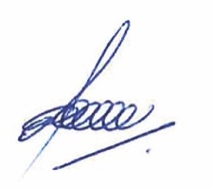

Osman Kasso
Chief Financial Officer
Frankston
7 October 2025


Peninsula Health
PO Box 52, Frankston,
Victoria 3199
(03) 9784 7777
peninsulahealth.org.au

